Bell Ringer #5
4/24/19
- Why did the Japanese attack Pearl harbor?
  - To make it easier to launch an attack on the West coast of the United States
  - To destroy ships and planes that threatened their expansion plans
  - To demonstrate support for Germany and Italy

- What was the turning point battle in the Pacific Theatre of the war? (hint: it made our naval forces equal to Japan’s)

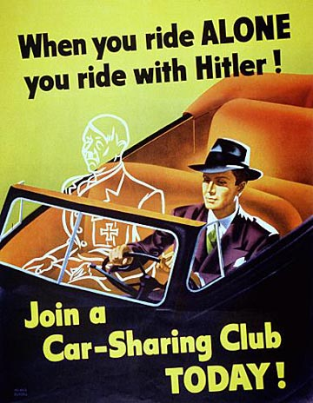
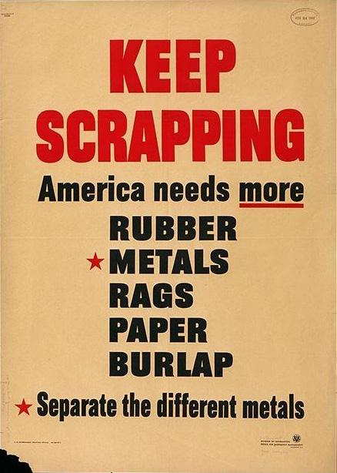
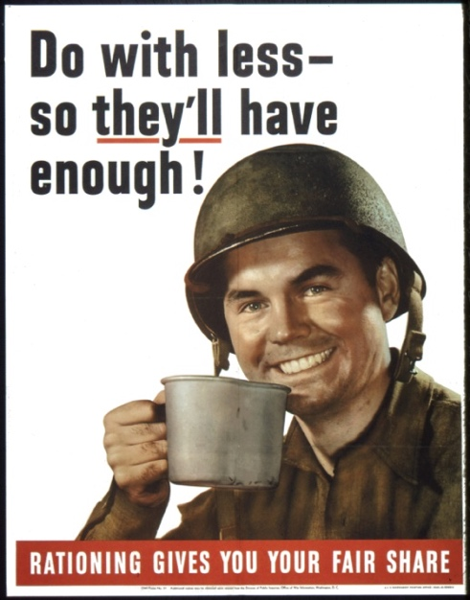

- These posters were trying to convince Americans that winning World War II required
  - Wage and price freezes
  - The sale of additional war bonds
  - Higher levels of taxation and spending
  - The conservation of scarce resources

