Bell Ringer #4
5/16/19
- Which American president was responsible for the desegregation of the US armed forces?
  - John F. Kennedy
  - Lyndon B. Johnson
  - Harry S. Truman
- During the 1950s, which of the following was the main goal of the civil rights movement in the United States?
  - Create completely separate social and economic institutions for African Americans
  - Encourage African Americans to migrate to Africa
  - Eliminate segregation and ensure political rights

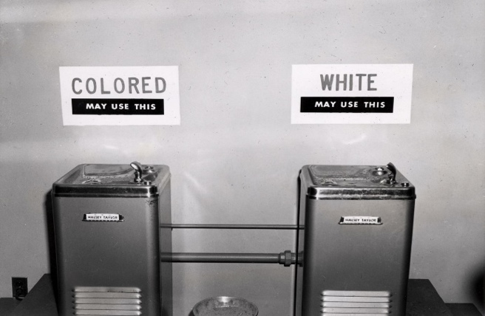

3. The situation demonstrated in the picture above is a direct result of which of the following?
  - The Great Migration
  - Passage of Jim Crow laws
  - The March to Selma

