Bel Ringer #4
1/28/29
- How did the settlers of the Great Plains deal with the challenge of building homes on the treeless prairie?

- Using your notes from Friday, which specific group of people do you think is targeted in the advertisement below?

  - Irish Immigrants
  - Exodusters
  - Nativists
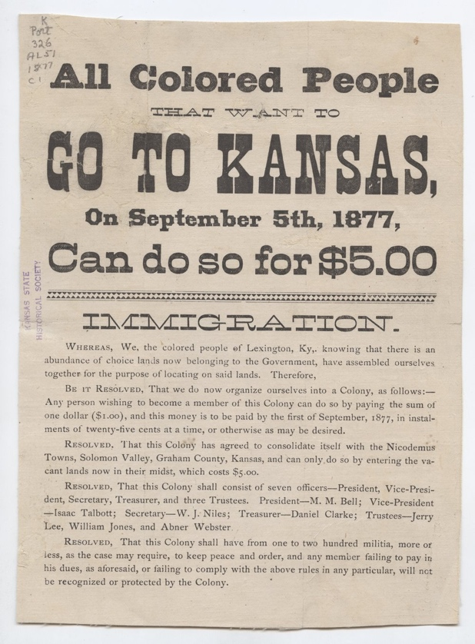

- Define the Homestead Act. What was the US Government trying to do by enacting laws like this?

