Christopher Columbus: Hero or Villain?

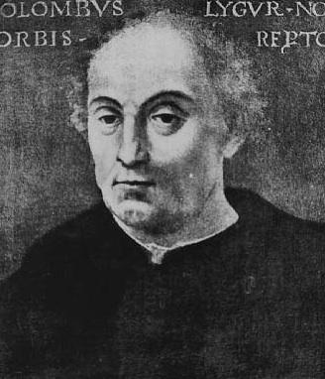 Introduction 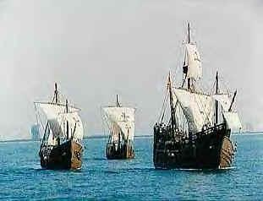

Recent historical interpretations of Christopher Columbus' voyages to the New World have created controversy surrounding the national celebration of Columbus Day. President Obama has formed a task force to answer the question should Columbus Day be abolished as a national holiday? The task force consists of Congressmen, business leaders, college professors, and the 9th grade class at Wakefield High School. The President has asked all members of the task force to write a short paper expressing his or her point of view. To assist task force members with their project, the President's advisors have provided several documents that give background information on the Columbus debate. Use the documents to support your argument for or against the celebration of Columbus Day.

The title of your paper should be "Christopher Columbus: Hero or Villain?" Be sure to state your position in the opening paragraph. Also cite information from the below documents to support your position. The paper should be a minimum of 3 paragraphs. Each paragraph should be 5 – 7 sentences. A paper should consist of an opening paragraph, one or more paragraphs to support your opinion, and a closing paragraph to sum up the topic and your position.

Document 1
Christopher Columbus kept a detailed record of his voyages to the New World. This is an excerpt from his journal on the day he first made contact with natives.

Saturday, 13 October 1492--At daybreak, great multitudes of men came to the shore… they came to the ship in canoes, made of a single trunk of a tree, wrought in a wonderful manner considering the country; some of them large enough to contain forty or forty-five men, others of different sizes down to those fitted to hold but a single person. They came loaded with balls of cotton, parrots, javelins, and other things too numerous to mention; these they exchanged for whatever we chose to give them. I was very attentive to them, and strove to learn if they had any gold. Seeing some of them with little bits of this metal hanging at their noses, I gathered from them by signs that by going southward or steering round the island in that direction, there would be found a king who possessed large vessels of gold, and in great quantities.

--Christopher Columbus (1492)

Document 2
Joel Barlow was an early American poet who lived from 1754 to 1812. The following is an excerpt from his poem The Vision of Columbus which hailed the explorer as a hero.

This extraordinary man, who was now about twenty-seven years of age, appears to have united in his character every trait, and to have possessed every talent, requisite to form and execute the greatest enterprises. He was early educated in all the useful sciences that were taught in that day. He had made great proficiency in geography, astronomy and drawing, as they were necessary to his favorite pursuit of navigation. He had now been a number of years in the service of the Portuguese, and had acquired all the experience that their voyages and discoveries could afford. His courage and perseverance had been put to the severest test, and the exercise of every amiable and heroic virtue rendered him universally known and respected.

Such was the situation of Columbus, when he formed and thoroughly digested a plan, which, in its operation and consequences, unfolded to the view of mankind one half of the globe, diffused wealth and dignity over the other, and extended commerce and civilization through the whole.

--Joel Barlow, The Vision of Columbus (1787)

Document 3
Many Americans do not consider Christopher Columbus to be an American hero, and oppose the celebration of Columbus Day as a national holiday. The following is an excerpt of an online petition asking Congress to change the name of the holiday to "First Americans Day."

The “Columbus Day” holiday is the only national holiday that is overtly insulting to millions of Americans. It is now universally understood that Christopher Columbus did not “discover” the American continent. That concept is a “Euro-centric” one that is deeply insulting to American Indians and many native-born Americans of all cultures. It is also historically incorrect. American Indian people have been on this continent at least 10,000 years, and scientists have proven that numerous other explorers had arrived on this continent from other parts of the world long before Columbus. It is also now known that many of the things we once believed about Christopher Columbus were myths, and that much of what we did not know about him would seriously tarnish his image, to say the least. This petition, however, is not meant to be an attack on Christopher Columbus, but rather an appeal for a holiday that is not insulting to any American. American national holidays should be days that bring a sense of pride and togetherness for ALL Americans, and stem from an “American perspective.” “Columbus Day” fails that test on all counts.

--from an online "Petition to Abolish Columbus Day" (1995)

Document 4

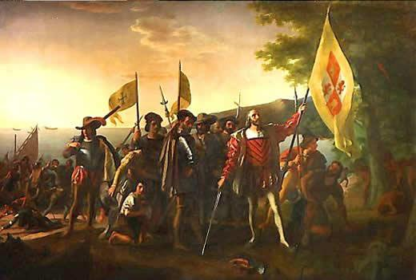

The Landing of Columbus (1847) by John Vanderlyn portrays the Age of Discovery. Commissioned by Congress, the work hangs in the Capitol Building in Washington, D.C.

Document 5
Michael Kammen earned a Ph.D. in history from Harvard University and is currently a professor of American cultural history at Cornell University.

Societies in fact reconstruct their pasts rather than faithfully record them…and do so with the needs of contemporary culture clearly in mind.

--Michael Kammen, Mystic Chords of Memory (1993)

Document 6
Howard Zinn is a professor of history at Boston University. He received a Ph.D. in history from Columbia University and is the author of more than 20 books. In the excerpt below, Zinn cites the writing of Bartolomé de las Casas, a Catholic priest who moved from Spain to the New World in 1508. De las Casas witnessed and opposed the harsh treatment of the natives by Spanish settlers.

When he arrived on Hispaniola in 1508, Las Casas says, "there were 60,000 people living on this island, including the Indians; so that from 1494 to 1508, over three million people had perished from war, slavery, and the mines. Who in future generations will believe this? I myself writing it as a knowledgeable eyewitness can hardly believe it...."

Thus began the history, five hundred years ago, of the European invasion of the Indian settlements in the Americas. That beginning, when you read Las Casas--even if his figures are exaggerations (were there 3 million Indians to begin with, as he says, or less than a million, as some historians have calculated, or 8 million as others now believe?)--is conquest, slavery, death. When we read the history books given to children in the United States, it all starts with heroic adventure--there is no bloodshed--and Columbus Day is a celebration.
--Howard Zinn, A People’s History of the United States (1980)

Document 7
Dr. Warren H. Carroll is a leading Catholic historian and author, and the founder of Christendom College. He received his Ph.D. in history from Columbia University. The following excerpt is from an article he wrote for The Catholic Social Science Review.

Let us begin, therefore, by defining the word “discovery” in the context of history. A discovery is made when an individual or a nation finds something or someone or some people or some places of special importance, not previously known to them. When any previously unknown people is first found by another people, that people may be said to have been discovered. People as well as places can be discovered. The fact that people live in places unknown to another people does not mean that they, and the places where they live, cannot be discovered. No people from any other part of the world ever discovered Europe; but Europeans discovered all other parts of the world.

In all of history, only the Europeans and the Polynesians of the south Pacific have been true discoverers, sailing for the explicit purpose of finding new lands, trading with their people, and colonizing them. And of all discoverers, Christopher Columbus was the greatest, because he accomplished the most against the highest odds. Before Columbus’ time all European voyages had followed coastlines, or crossed open seas to lands previously known or at least sighted by storm-driven ships. Only Columbus set off directly across a broad, unknown sea with no specific knowledge of how far it extended or what lay on the other side.

--Warren Carroll, Honoring Christopher Columbus (1992)

