European Feudalism & Manorialism Guiding Questions
- Describe the events of the fall of Rome and how they led to the rise of feudalism.

Germanic tribes invaded Roman borders, led to the collapse of centralized government, developed into many small, independent kingdoms.

- What is feudalism?

A social and political system existing in medieval Europe in which people worked and fought for nobles who gave them protection and land in return.

- Who was involved in feudalism? Create a feudal pyramid.

Kings gave land to nobles in exchange for service and loyalty. Nobles gave land to knights in exchange for loyalty and military service. Knights let peasants and serfs work the land in exchange for some of the crops/products.

- What is a fief?

Land held in feudal contract between a lord and vassal. Usually the vassal owed the lord some kind of loyalty and service.

- Describe the events of the Commendation Ceremony.

A commendation ceremony is a formal ceremony that evolved during the Early Medieval period to create a bond between a lord and his fighting man, called his vassal; contained the Oath of Homage (service) and Oath of Fidelity (loyalty).

- What is manorialism?

Economic system of medieval Europe in which lords and peasants worked together to support one another. The wealth of the lords came by the labors of the peasants who worked their lands. In return, the lords protected the peasants, offered them shelter, and insured that they were fed.

- Describe the components of a manor.

- Manor house/castle
- Three fields (one fallow, two active)
- Pasture
- Village
- Church
- Water source
- Craftsmen
- Bakery/mill
- Woods/forest

- Who benefits most from the manor? Who benefits least? Explain your answers.

The lord benefits the most from the manor system, keeping the land and a percentage of the crops/products produced. Serfs benefit the least, simply having the right to work and live on the land, though they were not allowed to leave.

Japanese Feudalism Guiding Questions

- How was Japanese feudalism similar and different from European?

Japanese Feudalism | Similarities | European Feudalism
- Buddhism  - Shogun has the true power, not emperor  - Japanese lords can adopt an heir of their choosing  - Women were expected to be tough and self-disciplined  - Samurai valued education | - Feudal government and social structure  - Royalty (kings/emperor)  - Nobles (lords/ daimyo)  - Warriors (knights/ samurai)  - Warrior codes (chivalry / bushido)  - Peasants worked land | - Christianity  - King holds the most power in kingdom  - Lords get their power from the king  - Oldest son inherits land  - Women considered weak  - Knights did not consider education important

- Who was involved in Japanese feudalism? Create a feudal pyramid.

Emperors were a figure head with no real power. Shoguns held the real, day to day, power over their land.

- Why did the Japanese emperor lose his power?

By the 1100s, the emperor’s power was so weakened that Japan collapsed into civil war. Unable to control the lords of Japan, the emperor lost his political power.

- Who was the Shogun and why was he powerful?

By 1192, Japan’s most powerful lord or noble had the emperor appoint him as Japan’s “Supreme Military Governor” or Shogun. For the next 600 years, the Shoguns were the real rulers of Japan, while the emperors acted as mere figureheads. The Shogun stood at the top of the Japanese feudal system. He was the most powerful lord in Japan. The Shogun was a military dictator.

- What was the relationship between the Daimyo and the Shogun?

A daimyo was a noble landowner or a lord. Daimyo controlled larges estates, given to them by the Shogun for loyalty and service.

- Who were Samurai and what was the Code of Bushido?

Samurai were warriors on horseback and fearless soldiers who carried swords. They believed that to die in battle was an honor. The Code of Bushido was the samurai’s code of honor and it demanded that a samurai be loyal to his lord and brave. A samurai had to obey orders and practice self-discipline, or control over one’s feelings and actions. Honor was the most important thing in his life. If a samurai lost his honor, he had to commit seppuku or hari-kari. He had to kill himself with his own sword. The Japanese believed that seppuku restored or brought back honor.

- What was life like in Japan during this era?

Buddhism and Shinto shaped much of Japan's culture. These religions affected Japanese art, architecture, food, novels and plays. The medieval Japanese borrowed a lot of their artistic ideas from China and Korea. Then, they went on to develop their own styles. The arts of Japan revealed the Japanese love of beauty and simplicity. The kimono was also introduced during this period. Women's kimonos had obis (wide sashes), which went around the waist and were tied elaborately in the back. Everyone wore kimonos.

- Describe the cultural diffusion between China and Japan.

- Language
- Religion
- Government
- Architecture
- City planning
- Art
- Music
- Clothing

The Crusades Guiding Questions

- What were the Crusades?

A series of military expeditions undertaken by Christian powers in the 11th, 12th, and 13th centuries to win the Holy Land from the Muslims.

- What is the significance of Jerusalem for Christians? Muslims?

Christians - Church of the Holy Sepulchre; it is located on a site which is central to the story of Jesus, his death, crucifixion and resurrection.

Muslims - Dome of Rock and the al-Aqsa Mosque. The mosque is the third holiest site in Islam. Muslims believe the Prophet Muhammad travelled here from Mecca during his night journey and prayed with the souls of all the prophets.

- Why did Pope Urban II call for the Crusades?

The leader of the Byzantine Empire asked for help from the west due to invading Muslim forces. The call was for Christian knights to help reclaim the Holy Land.

- Include a map of the Crusades.
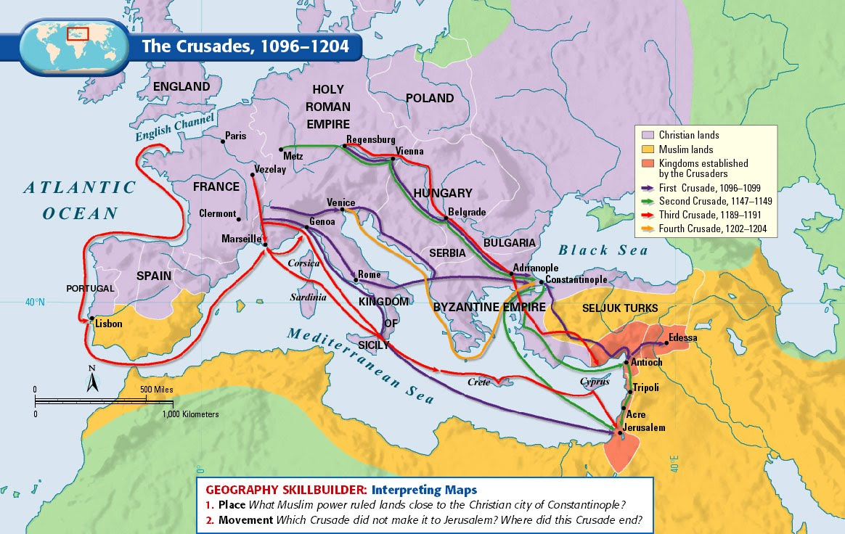

- Briefly describe the events of the First Crusade.

July 15, 1099 Christian warriors captured the city of Jerusalem and won a narrow strip of land.

- Briefly explain crusades 2-8.

Multiple attempts to recapture Jerusalem and other cities. Muslim army, led by Saladin, able to successfully keep the Christian forces at bay.

- Why did the Crusades fail for Christian warriors?

They could never maintain control over the Holy Land and the Crusades became less about religion and more about financial gain.

- What were the results of the Crusades?

Decreased the power of the Church, increased the authority of the king, increased trade, increased learning/universities

The Rise of Frankish Kingdoms Guiding Questions

- Where was Gaul? Who were the Franks?

Name given by the Romans to the territories where the Celtic Gauls lived, including present France, Belgium, and Luxemburg. Franks were Germanic-speaking people who invaded the Western Roman Empire. Dominating present-day northern France, Belgium, and western Germany, the Franks established the most powerful Christian kingdom of early medieval Western Europe.

- Who were the Merovingians?

First ruling family of Frankish descent, established with Clovis I.

- What were the main accomplishments of Clovis I?

Expanded the territory of the Franks, united the various Frankish kingdoms, and converted to Christianity.

- What were the main accomplishments of Charles Martel?

Stopped Muslim advance at the Battle of Tours, held the power as Mayor of the Palace, established the Carolingian Dynasty.

- Who were the Carolingians?

Family of Frankish aristocrats and the dynasty that they established to rule Western Europe. The name derives from the large number of family members who bore the name Charles, most notably Charlemagne.

- What were the main accomplishments of Pepin the Short?

Pope declared him as King of the Franks, expanded his territories, father of Charlemagne.

- What were the main accomplishments of Charlemagne?

United most of Western Europe, established the Holy Roman Empire, helped spread Christianity, preserved Greco-Roman culture
- Describe the development of the Holy Roman Empire.

December 25, 800 CE, Pope Leo III crowned Charlemagne Emperor of the Romans, establishing a multi-ethnic territory throughout western and central Europe.

Kievan Rus: The Rise of Russia

- Describe the geography of Eurasia, particularly the steppes.

West of the Ural Mountains in the region that runs from the Black Sea to the Baltic Sea. In the south was hilly grasslands called the steppe. In the north, it is densely forested, flat, and swampy. The Dneiper River, the Don River, the Volga River run through the region.

- Who were the Varangians? How did they influence the development of Russia?

Small bands of adventurers who descended from the north. Also known as the Rus and were most likely Vikings. Viking chief Rurik was invited by the Slavs to be king.

- Why was Kiev such an important city?

Kiev, or Kyiv, is a city on the Dnieper River from which the Vikings could sail by river and sea to Constantinople. From there, they had access to trade of products from far away.

- Describe the process by which Russia chose to become Eastern Orthodox (religion).

In 957, Princess Olga visited Constantinople and publicly converted to Christianity. Her son resisted Christianity, but her grandson, Vladimir, considered the faith. He sent out teams to observe the major religions and decided on Eastern Orthodoxy because of the splendid and grand buildings and the beauty of Constantinople.

- What was the significance of Yaroslav the Wise?

Yaroslav married off his daugthers and sisters to kings and princes of Europe, forming important alliances. He created a legal code, built the first library, and helped Christianity grow.

- How did the Mongols impact the development of Russia?

The Mongols established the Khanate of the Golden Horde in which Russians were allowed to follow their traditional customs, as long as they did not try to rebel. Mongols tolerated all religions, allowing Christianity to continue. Mongols demanded absolute obedience and tribute (payments). Mongols isolated the Russians from their neighbors, so Russia had little access to new ideas and inventions.

- How did Russia come to be ruled by a Czar (Tsar)?

Ivan III took the name czar, the Russian version of Caesar, claiming that Russia was to become the “third Rome.”

- What was the significance of Ivan III (the Terrible)?

Ivan openly challenged Mongol rule and in 1480 officially made a break with them. He refused to pay tribute and Russian and Mongol armies faced off at the Ugra River. Both sides refused to fight and Russia saw it as its liberation from Mongol rule.

The Hundred Years War Guiding Questions

- What were the causes of the Hundred Years War?

Controversy over succession of the French throne between England and France, conflict over territories in France

- Describe the military advantages of the British.

Weapons Technologies (longbow, crossbow); Avoid pitched battles; Engage in quick, profitable raids; Steal what you can; destroy everything else; Capture enemy knights to hold for ransom.

- Describe the military advantages of the French.

Population of about 16,000,000; far richer and more populous than England; at one point, the French fielded an army of over 50,000 and at most, Britain mustered only 32,000

- What were the events and results of the Battle of Poitiers?

Catastrophic defeat sustained by the French king John II at the end of the first phase of the Hundred Years’ War between France and England. Many of the French nobility were killed, and King John was left a prisoner of the English.

- What were the events and results of the Battle of Agincourt?

Decisive victory of the English over the French in the Hundred Years’ War. In 1413 the new king of England, Henry V, took the opportunity of a power struggle inside France to renew English claims to the French throne and invade.

- Describe the conditions of the Treaty of Troyes.

Charles VI’s son was declared illegitimate and disinherited; Henry V married Catherine, the daughter of Charles VI; Henry was declared the legitimate heir to the French throne!

- What was the significance of Joan of Arc?

Daughter of prosperous peasants who reported had divine visions of God telling her to defeat the British and drive them out of France. She was captured during an attack on Paris, fell into British hands, and was executed.

- What were the ultimate results of the war?

Despite Joan’s capture, the French advance continued. By 1450 the English had lost all their major centers except Calais. In 1453 the French armies captured an English-held fortress. There was no treaty, only a cessation of hostilities.

Knighthood & Chivalry Guiding Questions

- How did someone become a knight? Describe the process.

At age 7, a boy would be sent off to the castle of another lord to serve as a page. A page waited on his hosts and begin to learn and practice fighting skills. Around age 14, the page would become a squire. A squire acted as a servant to a knight. At the age of 21, a squire could become a full-fledged knight.

- Describe the armor and weaponry of a knight.

Knights wore chain mail (small metal rings linked together in a pattern to form a mesh) and metal plate armor (iron or steel plates that covered the entire body – suit of armor). Knights used daggers, lances, maces, flails, and swords.

- How does a knight fit in the feudal system?

Knights were considered lesser nobles, owing service to higher lords for the land they received.

- What type of events might a knight participate in during peacetime?

Knights maintained their necessary skills by participating in tournaments, jousts (two horsemen wielding weapons of joust with blunted tips), and melee (knights fighting one another on foot or mounted, either divided into two sides or fighting as a free-for-all).

- What was the code of chivalry?

Complex set of ideals, demanded that a knight fight bravely in defense of three masters – his earthly feudal lord, his heavenly Lord, and his chosen lady.

- What was the concept of “courtly love?”

Highly stylized code of behavior popular chiefly from the 12th to the 14th century that prescribed the rules of conduct between lovers, advocating idealized but illicit love.

- Describe the characteristics of medieval romance literature.

Idealizes Chivalry, noble hero-knight and his daring deeds; Women are idealized and held in high regard by hero-knight; Imaginative, vast, fairytale like setting; Mystery and supernatural elements abound; Repetition of the magical numbers 3 and 7.

- Find an example of medieval literature and provide a brief summary.

The Song of Roland (epic poem based on the based on the Battle of Roncevaux Pass), Le Morte d'Arthur (stories of King Arthur, Lancelot, and Guinevere)

The Magna Carta Guiding Questions

- What type of government was in place in England in the 13th Century?

Autocracy, Monarchy

- Give a brief background on King John.

John ruled from 1199-1216; failed as a military leader, losing lands in northern France and generally considered to be a failure as a political leader

- Why were the barons of England mad at King John?

John was cruel to his subjects, demanded high taxes, alienated the Church, and threatened to take away town charters giving self-government

- What are the basic principles of the Magna Carta?

Safeguarded feudal rights and limited the king’s power

- Why might the barons have wanted King John to make these promises?

They wanted to protect the rights of the people and guarantee that the king was not above the law.

- What lasting impact has this document had on England?

Led to protect of rights, development of Parliament

- What lasting impact has this document had on the rest of the world?

Foundations of future British government, American government, UN

The Black Plague (Black Death) Guiding Questions

- Give a brief description of a plague and/or epidemic.

A widespread occurrence of an infectious disease in a community at a particular time.

- How did the Famine of 1315-1317 weaken the overall population of Europe?

Climate changes in Europe produced three years of crop failures between 1315-17 due to excessive rain. As many as 15% of the peasants in some English villages died. One consequence of starvation & poverty was susceptibility to disease.

- How was the plague spread?

The nomadic Mongols likely carried infected Oriental Rat Fleas in their food supplies as they moved through China and other conquered regions. The disease spread with merchants along trade routes of Asia, southern Asia, southwest Asia (Middle East), and Africa. In 1345-46, A Mongol army besieged Kaffa, near Constantinople, spreading the disease to Europe for the first time. A year later, Italian merchants returned to Italy, unknowingly carrying the disease with them to rest of Europe

- Describe the symptoms and possible consequences of the plague.

Painful swellings called buboes in the lymph nodes, nausea, fewer, bleeding under the skin, seizures, pain, and then death.

- How did people in the Middle Ages attempt to treat the disease?

The swellings should be softened with figs and cooked onions. The onions should be mixed with yeast and butter. Then open the swellings with a knife… Take a live frog and put its belly on the plague sore. The frog will swell up and burst. Keep doing this with further frogs until they stop bursting. Some people say that a dried toad will do the job better.

- How did people attempt to stop the spread of the disease?

Plague doctor, leeching, pogroms against the Jews, flagellanti (Priests, friars, and monks who travelled from town to town to self-inflict “penance” for the sins of man)

- What was the result of the plague on Europe?

Around 1/3 of the total population of Europe was killed, 20-25 million deaths in Western Europe

- What were the political, economic, and social effects of the plague?

Collapse of the manorial system, population decline, urbanization, growing prejudice against Jews, decreased faith in the church

Mongols & China Guiding Questions

- Who were the Mongols?

Nomadic pastoralists (people who herd animals) located on the eastern steppes, in modern day Mongolia

- Describe the geography of the Eurasian steppes.

Vast area of dry grassland, stretching across much of the Eurasian landmass

- Who was Genghis Khan? What were some of his achievements?

Around 1200, a Mongol clan leader named Temujin sought to unify the Mongols under his leadership. He fought and defeated his rivals and by 1206 adopted the title of Genghis Khan, or “universal ruler.” Over the next couple of decades, Genghis Khan led the Mongols in conquering much of Asia.

- What was the Mongol Empire like at its height?

Conquered China, Kievan Rus, Persia, and other cities. By 1260, the Mongols divided their huge empire into Khanates, or kingdoms.

Khanate of the Great Khan, Khanate of the Chagatai, Khanate of Golden Horde, and the Ilkhanate.

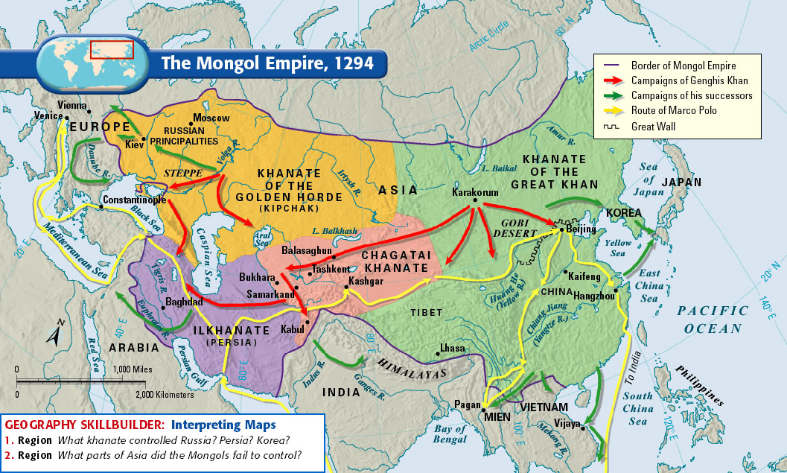

- What was China like under Mongol rule during the Yuan Dynasty?

Mongol rulers had little in common with their Chinese subjects. Because of these differences, Mongols kept themselves separate from the Chinese. Most of the highest level government positions went to Mongols or other foreigners. Kublai Khan encouraged foreign trade by inviting foreign merchants to the Chinese court.

- What was Kublai Khan? What were some of his achievements?

As China’s new emperor, Kublai Khan founded a new dynasty called the Yuan Dynasty, which lasted until 1368. Kublai Khan united China for the first time in 300 years and opened up China to greater foreign contact and trade.

- How did Japan resist Mongol invasion?

Typhoon storms (Kamikazes) destroyed many of the Mongol ships, forcing them to turn back to China.

- What as the Pax Mongolica? Compare it to the Pax Romana.

From the mid-1200s to the mid-1300s, the Mongols imposed stability, law, and order.

- What was the significance of Marco Polo in China?

Marco Polo visited China during the Mongol rule and served the Khan for 17 years before returning to Europe. He published a tale of journey, entitled The Travels of Marco Polo.

Islamic Kingdoms & Kingdoms of Africa Guiding Questions

- How was the Middle East the “crossroads of the world”?

The peninsula connects Europe, Asia, and Africa

- Describe the rise of Islam in the region.

Abu-Bakr, a loyal friend of Muhammad, was elected as the new leader of the Islamic community. Abu-Bakr, Umar, Uthman, and Ali (the first four caliphs) all knew Muhammad and became known as the “rightly guided” caliphs. When people began to refuse to pay taxes and some people declared themselves prophets, Abu-Bakr declared a jihad. Under the “rightly guided” caliphs, the Islamic empire greatly expanded.

- What caused the Sunni-Shi’a split?

Shi’a, (party of Allah), were the minority resistance group against the new rule of the Umayyads. Sunni, (followers of Muhammad’s example), where those who did not outwardly oppose the Umayyads.

- Describe the rise of the Abbasids.

In 750, a rebel group known as the Abbasids overthrew the Umayyads. When the Abbasids took over, they murdered as many members of the Umayyad family as possible. To solidify power, the Abbasids moved the capital to Baghdad, in modern day Iraq. The Abbasids established a strong bureaucracy to conduct the empire’s affairs. To support the bureaucracy, the Abbasids taxed land, imports, exports, and non-Muslim wealth.

- What advances in arts and science arose during Islamic rule?

Bedouin poetry, One Thousand and One Nights, calligraphy, expansion of medical knowledge, astronomy.

- What was the significance of the Gold-Salt trade in Ghana?

Some sources estimate that until 1350, at least two-thirds of the world’s supply of gold came from West Africa. By 800, Ghana had become a strong empire, built off the wealth of the gold trade. Berber traders carried salt from the sodium rich Sahara, along with cloth, weapons, and manufactured goods.

- How did Islam influence West African kingdoms?

By the end of the 11th century, Islamic advisers were helping guide the king run his kingdom. Although many rulers accepted and embraced Islam, many people stuck with their traditional animistic beliefs.

- Describe the significance of Mansa Musa and his hajj.

Mansa Musa was a skilled military leader who exercised royal control over the gold-salt trade and put down all rebellions. Mansa Musa took a hajj (religious pilgrimage) to Mecca from 1324 to 1325 to display the wealth of Mali to the rest of the Islamic world.

- Who was Ibn Battuta? What was his significance?

In 1352, one of Mansa Musa’s successors prepared to receive a traveler and historian from North Africa named Ibn Battuta. Battuta had traveled for 27 years, visiting most of the countries of the Islamic world. Battuta discovered that he could travel throughout Mali without fear of crime, however he criticized that the people of Mali did not follow a strict Islamic moral code.

Medieval Church Guiding Questions

- Which Christian church was dominate in Western Europe?

Roman Catholic Church

- How was the Church able to become so powerful?

When the pope crowned Charlemagne as the head of the Holy Roman Empire, the Church sought to influence both spiritual and political matters. Pope Gelasius I recognized that the Church and the State (government) conflicted for power.

- Describe the hierarchy of the Church.

The pope in Rome headed the Church Abbots & Archbishops Friars & Bishops Friars & Priests Monks & Nuns Ordinary Christians

All clergy, or members of the church, fell under the authority of the pope. Bishops settled disputes over Church teachings and practices. Local priests served as the main contact with the church for most of Europe.

- How did the Church try to help the people of the Middle Ages?

Established hospitals, charities, almshouses (poor houses), and asylums. Tried to help feed the poor and make sure all people received the care that they needed.

- Why was there a struggle between political leaders and the Church?

Both the Church and political leaders, like kings, wanted to have the most power in their realm. This led to many conflicts over property ownership, taxes, and wealth. The Church had canon law, pertaining to marriage and other religious practices.

The church resented lay investiture, in which church officials had to be appointed by a kind or nobles. The church banned the practice, but kinds and emperors fought back. In response, the church would excommunicate (kick out of the church) the leaders.

- What was the purpose of the Holy Inquisition?

The Inquisition was a powerful office set up within the Catholic Church in the 12th century to root out and punish heresy. Heresy is the belief or opinion contrary to Christian religious doctrine. Inquisitors would arrive in a town and announce their presence, giving citizens a chance to admit to heresy. Those accused of heresy were forced to testify. If the heretic did not confess, torture and execution were inescapable. Heretics weren’t allowed to face accusers, received no counsel, and were often victims of false accusations.

- Describe the significance of Thomas Beckett and Thomas Aquinas.

St. Thomas Becket, (born c. 1118—died December 29, 1170; canonized 1173, chancellor of England and archbishop of Canterbury during the reign of King Henry II. His career was marked by a long quarrel with Henry that ended with Becket’s murder in Canterbury Cathedral. He is venerated as a saint in the Roman Catholic Church and in the Anglican Communion.

St. Thomas Aquinas developed his own conclusions from Aristotelian premises, notably in the metaphysics of personality, creation, and Providence. As a theologian he was responsible in his two masterpieces, the Summa theologiae and the Summa contra gentiles, for the classical systematization of Latin theology. His doctrinal system and the explanations and developments made by his followers are known as Thomism.

- What was the architecture style of cathedrals and churches?

The cathedral was viewed as the representation of the City of God. Between about 800 and 1100, churches were built in the Romanesque style. The churches had round arches and a heavy roof held up by thick walls and pillars. The thick walls had tiny windows that let in little light.

In the early 1100s, a new style of architecture, known as Gothic, evolved throughout medieval Europe. The term Gothic comes from a Germanic tribe named the Goths. Gothic cathedrals thrust upward as if reaching toward heaven. Light streamed in through huge stained glass windows. Other arts of the medieval world were evident around or in the Gothic cathedral—sculpture, wood-carvings, and stained glass windows.

