Thomas Hobbes
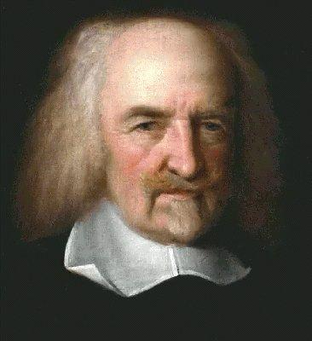
Thomas Hobbes is an English enlightenment philosopher who expressed his views in his book the Leviathan (1651). The horrors of the English Civil War convince him that all humans are naturally selfish and wicked. Without government to keep order, there would be war against every man and life would be “solitary, poor, nasty, brutish, and short.” Hobbes argued that to escape such a terrible life, people had to hand over their rights to a strong ruler. In exchange, they would gain law and order. Hobbes called this agreement the social contract. Hobbes believed the best form of government was an absolute monarchy which would impose order and demand obedience.

Key Ideas:
- All humans are naturally selfish and wicked
- Absolute monarchs are the best form of government
- Social Contract that people had to hand over their rights to a strong ruler in exchange for protection.

Thomas Hobbes
(write one and tell me what it means)
QUOTES:

1. “Curiosity is the lust of the mind.”

2. “It is not wisdom but Authority that makes a law.”

3. “Science is the knowledge of consequences, and dependence of one fact upon another.”

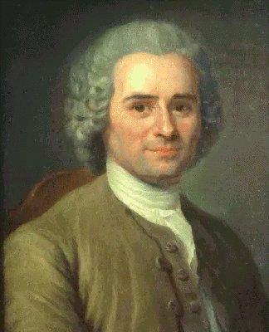
Jean Jacques Rousseau
Rousseau is a French enlightenment philosopher who was passionately committed to individual freedom. Rousseau wrote The Social Contract (1762) that idealized the “state of nature” that is a state of peace and equality. Rousseau believed that all men were born equal and free. He believed that the only good government was one that was freely formed by the people and guided by the “general will” of society – that is a direct democracy. Under such a government, people agree to give up some of their freedoms in favor of the common good. Like John Locke, Rousseau believed that a legitimate government came from the consent of the governed (the people).

Key Ideas:
- The Social Contract (1762) – stressing a direct democracy that is freely formed by the people and guided by the “general will” of society.
- Ideal form of government is a direct democracy
- All men are born equal and free
- Influenced thinkers and politicians including Thomas Jefferson, Thomas Paine, John Locke, and George Mason.
- Ideas appear in Thomas Jefferson’s Declaration of Independence and the Preamble of the Constitution.

Jean Jacques Rousseau
(write one and tell me what it means)
QUOTES:
1. “Man is born free and everywhere he is in chains.”

2. “Each of us puts his person and all his power in common under the supreme direction of the general will; and in a body we receive each member as an indivisible part of the whole.”

3. “The world of reality has its limits; the world of imagination is boundless.”

John Locke
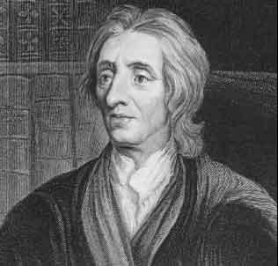
John Locke is the founder of the American form of government. He wrote two important books: Two Treatises on Government and Essays on Civil Government. He believed that all people have natural rights including life, liberty and property. He also believed that the foundation of government is the consent of the people. That means that government exists to protect the natural rights of people. People give part of their natural rights to government to govern and protect the greater good. When governments no longer protect people’s natural rights, people should overthrow the government and create a new one that they feel better protects their rights.

Key Beliefs:
- Natural rights of life, liberty and property
- Government should protect people’s natural rights
- Influenced key American thinkers and politicians such as Thomas Jefferson, Benjamin Franklin and John Adams
- Ideas appeared in Thomas Jefferson’s Declaration of Independence (1776) and George Mason’s Virginia Declaration of Rights.

John Locke
(write one and tell me what it means)
QUOTES:
1. “All mankind... being all equal and independent, no one ought to harm another in his life, health, liberty or possessions.”

2. “No man's knowledge here can go beyond his experience.”

3. “Every man has a property in his own person. This nobody has a right to, but himself.”

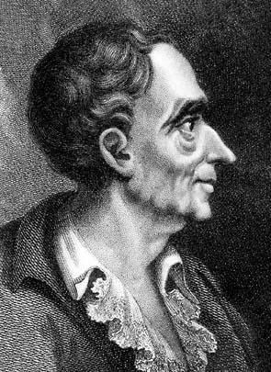
Baron de Montesquieu
Montesquieu believed that Great Britain was the best governed and most politically balanced country. The British King and his ministers held executive power and carried out the laws of the state. The members of Parliament held legislative power and made the laws. The judges of the English courts held judicial power and interpreted the laws to see how each should be applied to a specific case. Montesquieu called this idea the separation of powers. In his book, On the Spirit of Laws (1748), Montesquieu proposed that the powers of government should be divided into three branches – the legislative, executive and judicial branches. Each branch would have equal power. However, a system of checks and balances would be needed to make sure one branch does not become too powerful. His ideas about separation of powers and checks and balances became the basis for the United States Constitution.

Key Ideas:
- Separation of Powers (3 Branches of Government)
  - Executive (enforce laws)
  - Legislative (make laws)
  - Judicial (Review Laws)
- Checks and Balances to prevent one branch from becoming too powerful
- Influenced American politicians including Thomas Jefferson and James Madison.
- Ideas appear in the United States Constitution.

Baron de Montesquieu
(write one and tell me what it means)
QUOTES:
1. “In order to have liberty, it is necessary that the powers of the
government be separated.”

2. “To become truly great, one has to stand with people, not above them.”

3. “Liberty is the right of doing whatever the laws permit.”

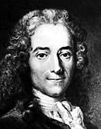
Voltaire
Probably the most brilliant and influential of the philosophes was Francois Marie Arouet. He used the pen name Voltaire and published more than 70 books. Voltaire used satire against his opponents and made fun of members of the church, kings, and government. His sharp tongue made him enemies at the French court and he was sent to prison twice. After his second term in prison, he was exiled to England for more than 2 years. Although he had many enemies, Voltaire fought for tolerance, reason, freedom of religious belief and freedom of speech. He used his pen as if it were a deadly weapon in a thinker’s war against humanity’s worst enemies – intolerance, prejudice, and superstition.

Key Ideas:
- Freedom of Religion and Freedom of Speech
- Influenced many politicians including Thomas Jefferson, James Madison, Robes Pierre.
- Ideas appear in the United States Bill of Rights (1st Amendment) and the French Declaration of Rights of Man and Citizen.

Voltaire
(write one and tell me what it means)
QUOTES:
1. “Those who can make you believe absurdities can make you commit atrocities.”

2. “I do not agree with a word you say, but I will defend to the death your right to say it.”

3. “It is difficult to free fools from the chains they revere.”

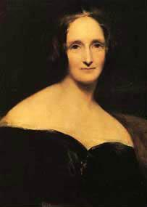
Mary Wollstonecraft
Mary Wollstonecraft was a strong advocate for education for women and women’s equality. She published the essay Vindication of the Rights of Woman (1792). In the essay, she disagreed with Rousseau that women’s education should be secondary to men’s. Rather, she argued that women, like men, need education to become virtuous and useful. Wollstonecraft also urged women to enter the male-dominate fields such as medicine and politics.

Key Ideas:
- Women’s Equality
- Ideas influenced many women’s rights advocates including Abigail Adams.
- Ideas are found in the women’s rights groups in Europe and North America and eventually the 19th Amendment of the United States Constitution – but not until 1920.

Mary Wollstonecraft
(write one and tell me what it means)
QUOTES:
1. “Virtue can only flourish among equals.”

2. “I do not wish them [women] to have power over men; but over themselves.”

3. “Strengthen the female mind by enlarging it, and there will be an end to blind obedience.”

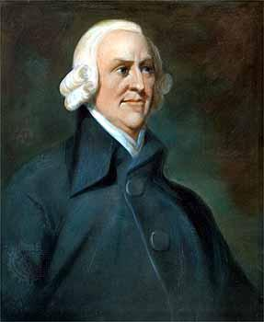
Adam Smith
During the Enlightenment, French thinkers known as physiocrats focused on economic reforms. Physiocrats rejected mercantilism, which required government regulation of the economy to achieve a favorable balance of trade (exporting more than you import). Instead they argued for Laissez Faire, meaning “leave it alone,” approach to the economy. Laissez Faire allows businesses to operate with little to no government interference. It also supports free trade and is against taxes on imported goods (called Tariffs). Scottish economist Adam Smith was greatly admired among physiocrats. He wrote the Wealth of Nations which argued that the free market should be allowed to regulate business activity. Smith tried to show how manufacturing, trade, wages, profits, and economic growth were all linked to the market forces of supply and demand. Wherever there was a demand for a good, suppliers would meet that demand in order to gain profits. Smith was a strong supporter of Laissez Faire. However, he felt that government had a duty to protect society, administer justice, and provide public works. Adam Smith is known as the “Father of Capitalism.” Capitalism is an economic system based on a free market and free enterprise.

Key Ideas:
- Laissez Faire
- Supported free trade
- Against Tariffs
- Free market should be allowed to regulate business activity
- “Father of Capitalism”
- Ideas influenced Alexander Hamilton and other founders of the United States government.
- Ideas are found in the United States economic system.

Adam Smith
(write one and tell me what it means)
QUOTES:
1. “There should be no government regulations on trade.”

2. “No society can surely be flourishing and happy, of which the far greater part of the members are poor and miserable.”

3.“The real tragedy of the poor is the poverty of their aspirations.”

