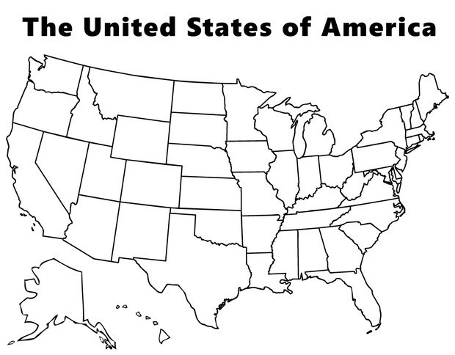

Directions: For this course, it is important to understand the geography of the U.S. Use the word bank below to fill in the map of the United States. Try to identify as many as possible before using help. For additional study and practice, go to https://online.seterra.com/en/vgp/3003 .

Word Bank:

Alabama
Alaska
Arizona
Arkansas
California
Colorado
Connecticut
Delaware
Florida
Georgia
Hawaii
Idaho
Illinois
Indiana
Iowa
Kansas
Kentucky
Louisiana
Maine
Maryland
Massachusetts
Michigan
Minnesota
Mississippi
Missouri

Montana
Nebraska
Nevada
New Hampshire
New Jersey
New Mexico
New York
North Carolina
North Dakota
Ohio
Oklahoma
Oregon
Pennsylvania
Rhode Island
South Carolina
South Dakota
Tennessee
Texas
Utah
Vermont
Virginia
Washington
West Virginia
Wisconsin
Wyoming

