Settling West Notes
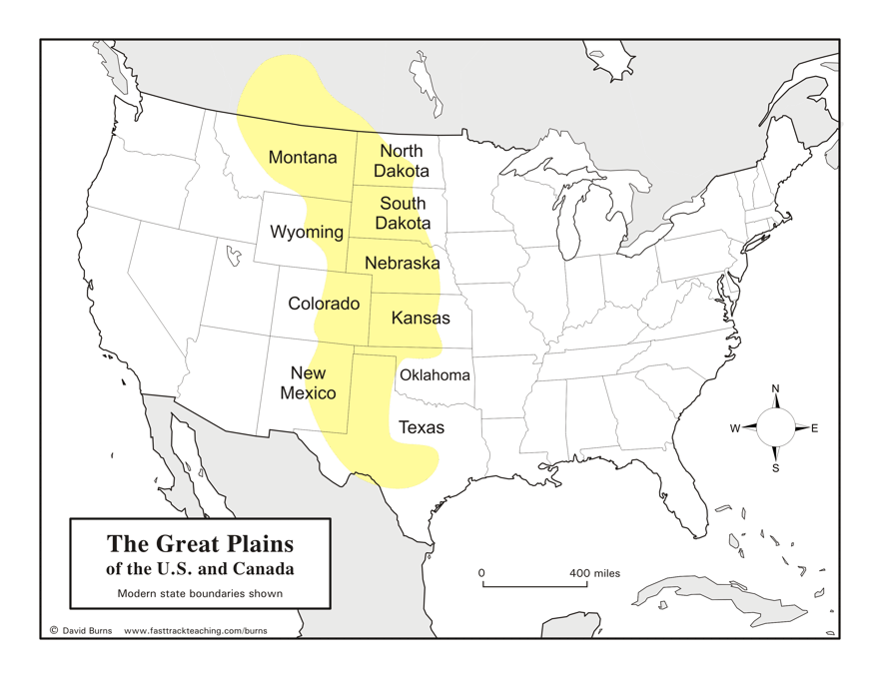
Great Plains
- Great plains –

- __________________________ and __________________ - largest and most resistant tribes on the plains
- What was the significance of the buffalo to tribes on the plains?

- Why did tribes on the plains not understand the concept of “land ownership?

- What were some new economic opportunities that drew settlers westward in the mid-late 1800s?

Clashes with Native Americans
- 1834 – Fed gov’t designated the Great Plains as one large ____________________________________ for NA tribes.
- 1850s – Fed gov’t created ___________________________________ for each tribe.
  - Allowed for ___________________________________ expansion.
- During the Massacre at Sand Creek (1864), the _____________________________ tribe experienced a mass killing of 150 people by US troops led by Col. Chivington.
- The Treaty of Ft. Laramie –

  - Never signed by _______________________________________, the Sioux leader
- The Battle of _______________________________________________ (1876) is also known as Custer’s Last stand because…

- What is the significance of the Battle of Wounded Knee (1890)?

Native American Assimilation
- 1881 – Helen Hunt Jackson published _________________________________________ to expose NA treatment by fed gov’t
- Assimilation –

- ______________________ (1887) – aimed to “________________________________” NAs, provided 160 acres of reservation land to each NA family.
  - Rest of the land would be sold to settlers $ to help NAs start ______________
  - By 1930s, 2/3 land bought by white settlers, NAs got no $

Growing Cattle Business
- Cattle, mostly __________________________________, were brought from Texas to ranges via cattle trails (ex: _______________________________ Trail).
- Which 2 inventions allowed for the growth of the cattle and beef industry? How?

Cowboys
- What were some characteristics and duties of cowboys in the mid-late 1800s?

End of the Open Range
- Why did the land on the Great Plains become unprofitable by the late 1800s?

