Manifest Destiny
A painting by John Gast 1872
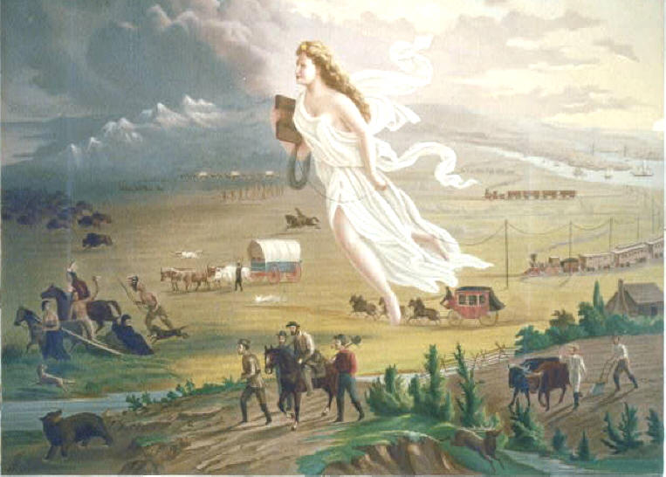

Based on the concept of manifest destiny interpret the painting above:

