Matching Cards: You can use these cards a number of ways.
- Finders Keepers: After the Supreme Court Power Point you can use these as a close activity. Pass out the cards and have students find their match.
- Warm up activity
- Review for a test
- Provide pairs a set of cards and they have to match them.

1896. The southern states started passing Jim Crow laws that segregated blacks and whites. It was during this time that a free black man boarded a train and sat in the white car. He sued saying it was unconstitutional to be told to ride in the black car. The judge ruled that it was constitutional according to the 14 amendment of separate but equal. | Plessy v. Ferguson  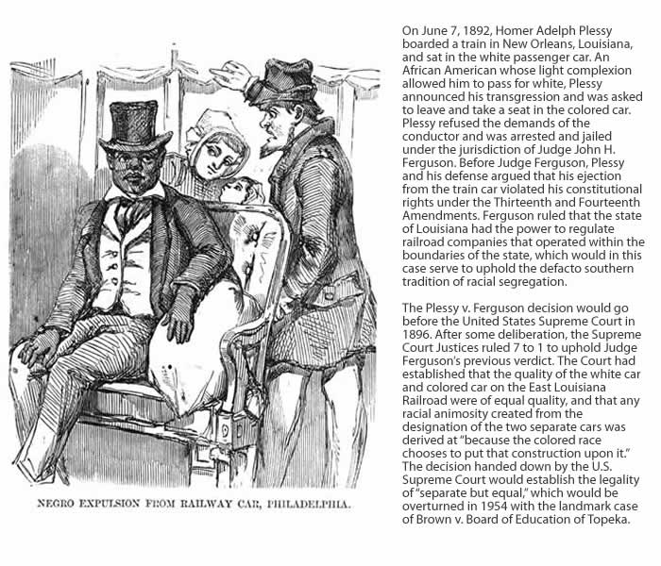
1857. He was born a slave. He tried to buy his freedom for himself and his family, but was denied. With the help of abolitionist he sued for his freedom.  The Supreme Court decided:  - Slaves whether imported or born in the US, were not protected under the constitution.  - Slaves could never be US citizens.  - Congress couldn’t prohibit slavery.  - Slaves were “chattel” and could not be taken from owners without legal process. | Scott v. Sanford  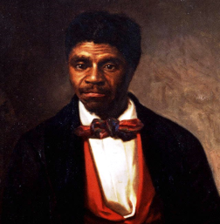
1961. The Police department got a tip that a lady and her daughter were hiding a bomb fugitive. They entered her house without a search warrant and found questionable material in her basement. They seized the “evidence” and Mapp was arrested.  Mapp was convicted due to the evidence and took it to the Supreme Court.  The court found that the evidence was found under "unreasonable searches and seizures" and reversed the lower court’s decision. (4th Amendment) | Mapp v. Ohio
1966. Supreme Court stated that before individuals are interrogated law enforcement must inform them about their constitutional rights. | Miranda v. Arizona  You have the right to remain silent…..
They wanted to wear arm bands to protest the Vietnam War.  The school principals said if they were to wear the armbands they would be suspended.  The Supreme Court’s decision was based on the First Amendment (free speech). It also defined the constitutional rights of students in U.S. public schools. | Tinker v. Des Moines  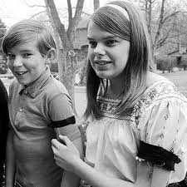
1973. She wanted to have an abortion, but it was illegal under TX state law.  The Supreme Court ruled that under the 14 Amendment “it is a fundamental right under the US Constitution” for women to have an abortion. | Roe v. Wade  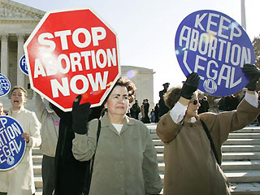
1974. President Nixon tried to use his executive powers to prevent handing over incriminating evidence against him in a criminal investigation. (Watergate)  The Supreme Court ruled against Nixon. In doing so they set precedent showing that the president was not above the law. | U.S v Nixon  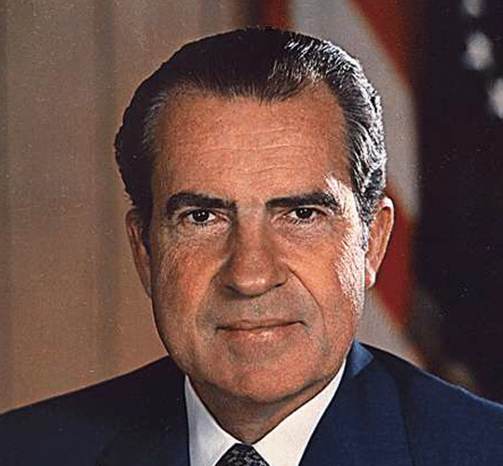
1982. He was a suspected drug dealer. The police pulled him over and searched his car without a search warrant. They found and opened a brown paper bag and a small leather bag which contained drugs and money. His lawyer sued for illegal search of closed containers.  The Supreme Court ruled that during a search by police, the scope (or area) of the search is defined by the item sought (look for). | Ross v. U.S.  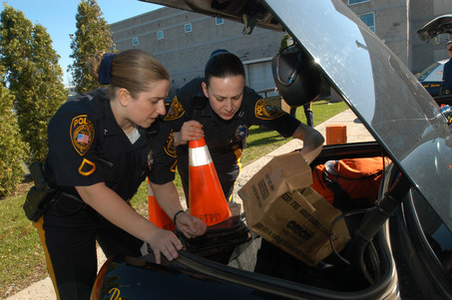
1985. Two high school freshman were caught smoking in their high school bathroom.  One of the student’s purse was searched and drug materials were found. Her locker was searched and information about her drug dealing was revealed. There was never a search warrant.  T.L.O fought the search and said it violated her 4th Amendment rights against unreasonable searches.  The Supreme Court held that the search was reasonable. | T.L.O v. New Jersey  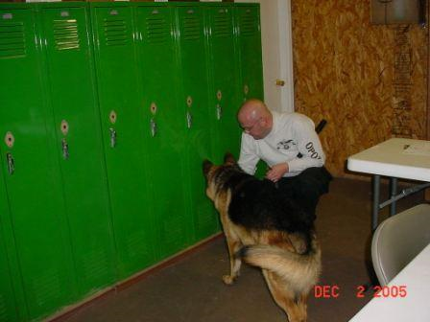
1954. Thirteen parents sued the Topeka, Kansas Board of Education for not providing equal school accommodations for their children.  The Supreme Court ruled that “separate educational facilities are inherently unequal.“ It was ruled in violation of the equal protection law of the 14 Amendment. | Brown v. Board of Education  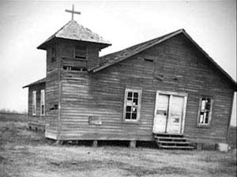
1803. Supreme Court has the power to declare laws and actions unconstitutional. | Marbury v. Madison  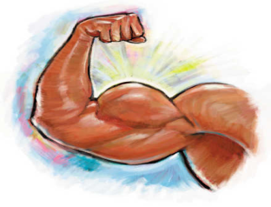
1819. Congress can create a national bank, a power implied in the elastic clause. | McCulloch v. Maryland  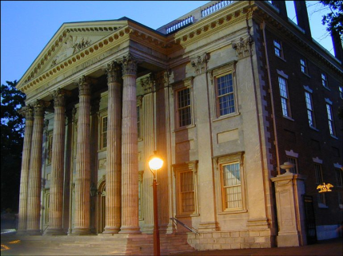
1824. Congress has the power to regulate interstate commerce. | Ogden v. Gibbons  