Study Guide Unit 9 Name:_____________________________________________________

1. Ownership of shares of a corporation is called what?

2. In a recession, the government might increase spending, and decrease taxes what could happen to our economy if that happens?

3. What happens during a trough?

4. What was the Sherman Antitrust Act about?

5. Why could monopolies be bad for a free market economy?

6. What is a natural monopoly?

7. Define the following:
Frictional unemployment:

Seasonal unemployment:

Cyclical unemployment:

Structural unemployment:

8. How does inflation affect consumers?

9. Who controls the Federal Reserve Policies?

10. What does the Federal Reserve charge on its loans to commercial banks?

11. Name a negative of free trade?

12. What does the Federal Open Market Committee do?

13. Who owns a corporation?

14. How does the stock market work?

15. What does Monetary Policy mean?

16. What eliminates tariff and other economic tariffs?

17. How are quotas used in international trade?

18. What are primary goals for business owners?

19. Who makes decisions for stockholders?

20. What is inflation?

21. What does GDP mean?

22.What does the Consumer Price Index do?

23. What does fiscal policy mean?

24. What does trade deficit mean?

25. Label the graph with peak, trough, contraction, expansion.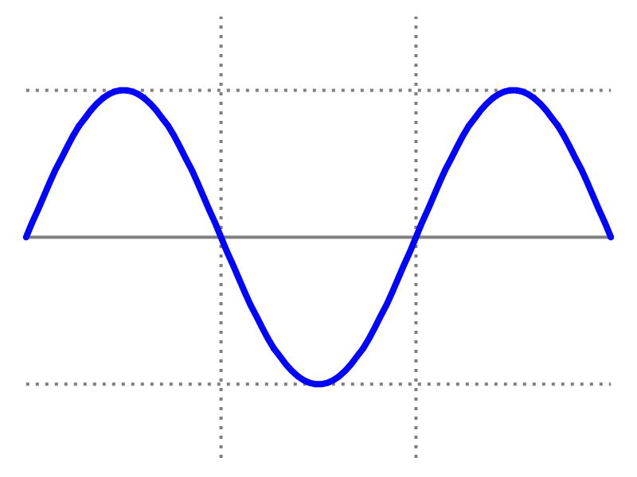

26. Define each of the following:
-Peak:
- Contraction
-Trough
-Expansion

27. What is an oligopoly?

28. What is protectionism policy mean?

29. What is NAFTA?

TEST 5/8:
WHAT IS DUE:
Essential Questions
Study Guide
Current Event

