Unit 3 Study Guide: Imperialism & WWI
Imperialism:
1. What was the United States’ first step in imperialism?

2. The following are all examples of____________________.
- Sea power is the key to national greatness
- United States missionaries spread Christian principles.
- The Anglo-Saxon civilization is the best in the world.
- sugar plantations in Hawaii were developed by Americans.

3. Which U.S. president oversaw the construction of the Panama Canal?

4. In the 1890s, the main goal of those who supported United States imperialism was to
- Obtain overseas markets and naval bases
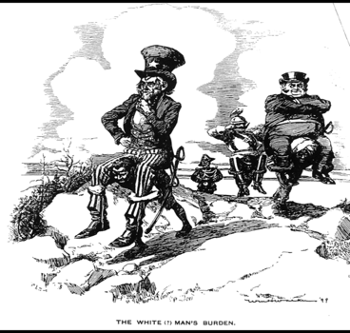
- Bring self-government to areas under United States control
- Spread democracy to Africa and Latin America
- Defend against attacks by enemy nations

5. What is the statement that is being made by this political cartoon about
imperialism?

6. Who was Queen Liliuokalani and what was her attitude on American
annexation of Hawaii?

7. In his book The Influence of Sea Power in History, Alfred Thayer Mahan wrote that “the ships of war of the United States, in war will be like land birds, unable to fly far from their own shores.”

According to the above quote, what was Mahan’s important concern about the U.S. Navy?

Vocab:
Roosevelt’s Corollary-
Monroe Doctrine-
Open Door Policy -
Joseph Pulitzer-
William Randolph Hearst-
Spanish-American War:
1. What major event sparked the Spanish-American War?

2. In which geographical area did the United States concentrate its effort to expand its influence during the late 1800s?

3. What followed after the American acquisition of the Philippines at the end of the Spanish-American War?

Vocab:
Emilio Aguinaldo-
Teller Amendment-
Platt Amendment-
World War I:
Why did Wilson ask Congress to declare war on Germany?

What was the role of women during the First World War?

Why did Russia have to pull out of the war in 1917?

What leader of the Food Administration encouraged Americans to create victory gardens and to participate in meatless days?

What ways did the fed gov’t raised money for the war effort?

What was a common belief held by anti-immigrant nativists after World War I?

What did Wilson hope to accomplish with the League of Nations?

Vocab:
Wilson’s Fourteen Points
Office of Public Information
John Pershing
Battle of Meuse-Argonne
Allied Powers
Central Powers
Zimmerman Telegram
Espionage Act & Sedition Act

