Unit 6 Study Guide: Early Cold War and Korean War
Directions: Use your notes, bell ringers, and class activities to complete the following study guide. Completion of this study guide will result in an additional 5 points on the unit test, up to a 100%.
Origins of the Cold War:
1. What is the most likely reason Stalin insisted on a Soviet-backed satellite states between the Soviet Union and Western Europe?

2. How could relations between the U.S. and USSR be described following the conclusion of WWII?

3. What event(s) led to the establishment of the Berlin Airlift?

Key Terms:
Marshall Plan-
Truman Doctrine-
United Nations-
Warsaw Pact-
NATO-
Potsdam Conference-
Satellite Nations-

Korean War:
What is the significance of the 38th Parallel?

What are three major the results/impacts of the Korean War?

Escalating Cold War:
1. Why the U.S. adopt a policy of “containment” during the Cold War?

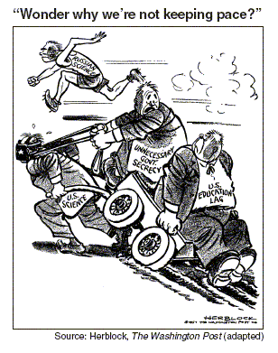

2. Which event of the 1950s most likely led to the publication of this cartoon?

Key Terms:
Iron Curtain-
Arms race-
Espionage-
Space Race-
Sputnik-

Cold War at Home:
1. What is the most likely reason Senator Joseph McCarthy was discredited?

2. Why did many in the U.S. build fallout shelters in the years after WWII?

3. What role did the U.S. play in the Bay of Pigs Invasion?

4. What nearly led to war between the U.S. and Soviet Union in 1962?

5. In the 1950s, Julius and Ethel Rosenberg were convicted and sentenced to death for what crime?

6. Television programs in the 1950s often emphasized what?

Key Terms:
Hollywood Ten-
House Un-American Activities Committee-
McCarthyism-
Dr. Benjamin Spock-
Beatniks-

