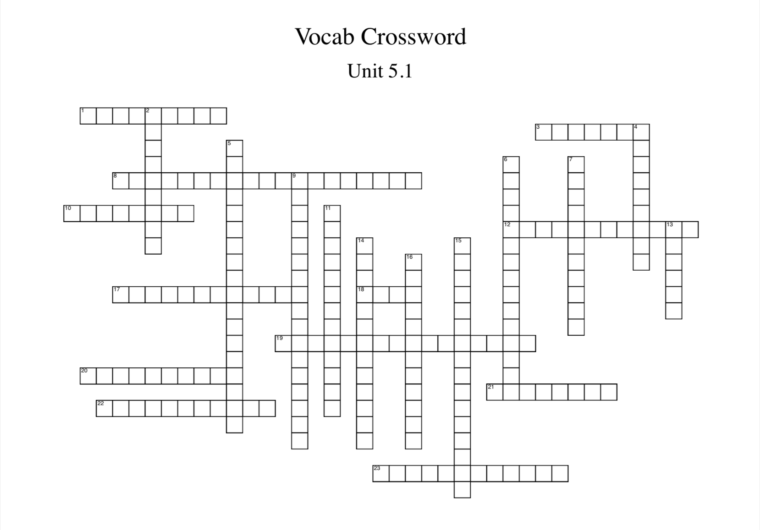

**Word Bank:**

dictator

totalitarian

communism

appeasement

genocide

Holocaust

concentration camp

Allies

Axis

Lend-Lease Act

Joseph

Stalin

Benito Mussolini

Adolph Hitler

Winston Churchill

Hideki Tojo

Dwight D. Eisenhower

fascism

Manchuria

Neutrality Act of 1935

Munich Conference

America First

Pearl Harbor

Final Solution

