Bell Ringer #3
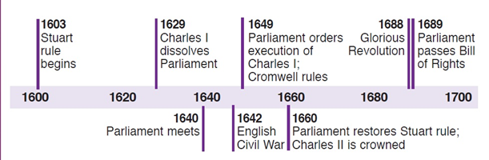
10/30/19

1. When was King Charles I executed by Parliament?
a) 1660 c) 1649
b) 1629

2. How many years passed between the start of the Stuart’s rule and the restoration of the Stuarts to the throne of England?
a) 57 years c) 35 years
b) 46 years d) 68 years

3. What is a Huguenot? (Hint: Use ch. 21.2 notes to help you)

