Bell Ringer #4
11/4/19

- What was the conflict between Charles I and Parliament known as? (use your textbook guide Ch. 21.5)

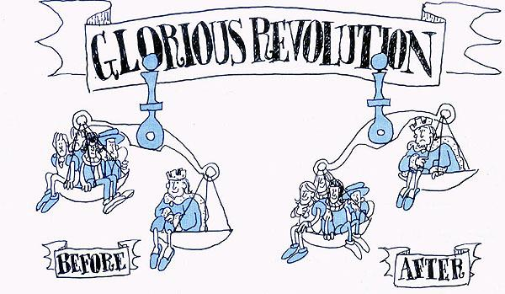

- According to the cartoon, what was one significant change that occurred from the Glorious Revolution?
  - The population of England grew
  - Parliament began to add in more members to balance the House of Commons and Lords
  - England switched from an absolute monarchy to a representative democracy
  - The balance of power shifted from the monarch to the people

- What was another name given to the Glorious Revolution? (use your textbook guide Ch. 21.5)

