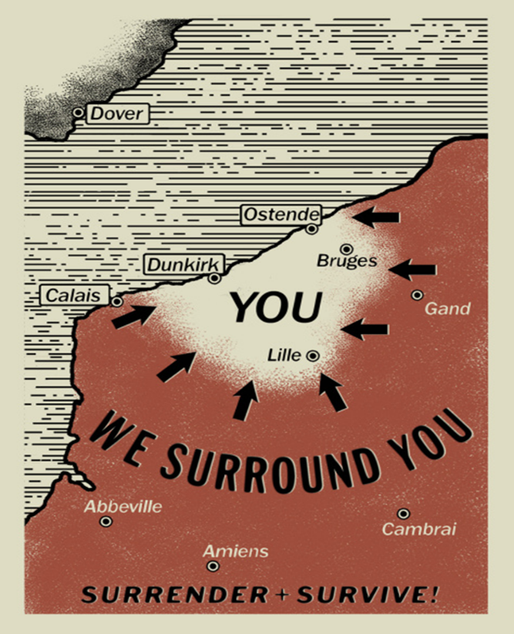
Bell Ringer #3
12/19/19
- What major event of early WWII is described in this image?
  - Operation Barbarossa (invasion of Soviet Union)
  - Operation Overlord (D-Day invasion of the beaches at Normandy)
  - Operation Dynamo (evacuation of Allied troops from Dunkirk)

- What would be the purpose of a leaflet (flyer) like this?
  - To represent facts instead of opinions
  - To encourage an alliance between France and Germany
  - To decrease the morale of Allied soldiers

Use the following excerpt to answer qyestion #3:
"Yesterday, December 7th, 1941 -- a date which will live in infamy -- the United States of America was suddenly and deliberately attacked by naval and air forces of the Empire of Japan… Indeed, one hour after Japanese air squadrons had commenced bombing in the American island of Oahu, the Japanese ambassador to the United States and his colleague delivered to our Secretary of State a formal reply to a recent American message. And while this reply stated that it seemed useless to continue the existing diplomatic negotiations, it contained no threat or hint of war or of armed attack." - Franklin D. Roosevelt, December 8, 1941

- To which event is US President Roosevelt referring?
  - Battle of Midway c. Bataan Death March
  - The bombing of Pearl Harbor d. The London Blitz

