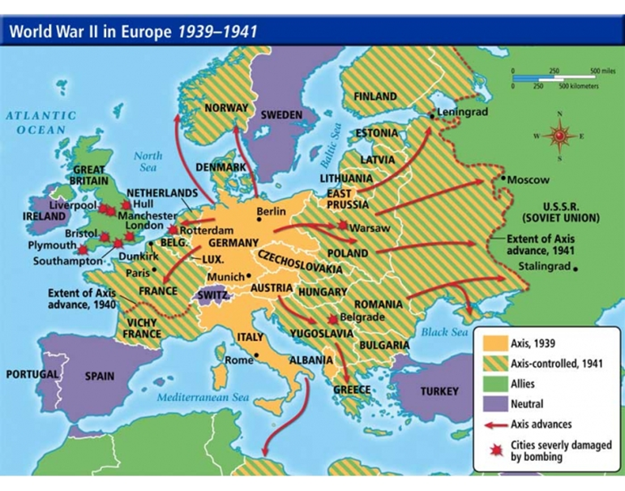
Bell Ringer #4: 12/20/19
- The map entitled “World War II in Europe, 1939-1941” shows several bombings in Great Britain. These bombings took place during which event?
a. The Blitz, where German forces lead airstrikes over British cities
b. The D-Day invasion of Normandy.
c. Italy’s bombings of western European countries to bring more Allied countries into war.

"I had then set up a committee of top men and had asked them to study with great care the implications the new weapons might have for us… They recommended further that it should be used without specific warning... I had realized, of course, that an atomic bomb explosion would inflict damage and casualties beyond imagination. On the other hand, the scientific advisors of the committee reported... that no technical demonstration they might propose, such as over a deserted island, would be likely to bring the war to an end. It had to be used against an enemy target.” – US President Harry S. Truman

- Why did President Truman feel that the atomic bomb had to be used against enemy targets?
  - Japan would not surrender unless the bomb was used against them.
  - Demonstrating the bomb’s power at a test site would convince Japan to surrender.
  - Japan already attacked Pearl Harbor with the same weapon.

- In your opinion, was the use of atom bombs against Japan the correct choice?

