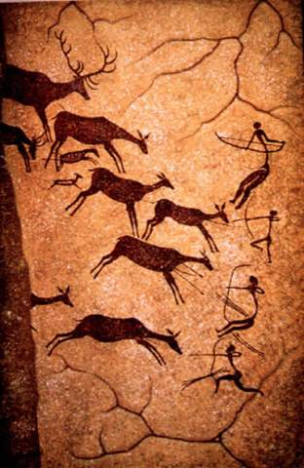
World History Final Exam Review

- By studying the image to the left, what could a historian learn about the civilization that created this cave painting?
  - What types of clothing they wore c. How they acquired food
  - New writing styles d. what types of music they liked

- What event began the Neolithic Era?
  - Discovery of fire c. Agricultural Revolution
  - Ice Age d. New Stone Age

- Which of the following is an element of a civilization?
  - Irrigation ditches c. Use of fire
  - Specialized workers d. City walls

- Which development most enabled early peoples to form permanent settlements?
  - Fertile soil c. Power for factories
  - New territories d. Areas for recreation

- Which of the following is considered to be an artifact?
  - Tools c. Government
  - River valleys d. Religion

- Which of the following was a direct result of the Neolithic Revolution?
  - Decline in population c. Spread of disease
  - Building of disease d. Cultural diffusion

“If a seignior (noble) has knocked out the tooth of a seignior of his own rank, they (the police) shall knock out his tooth… but if he has knocked out a commoner’s tooth, he shall pay one-third token of silver.” – Code of Hammurabi

- Which element of ancient law does the above excerpt of the Cold of Hammurabi illustrate?
  - All men were equal under the law c. Fines were always more preferable than punishment
  - Division existed between social classes d. Cultural diffusion

- Most of what we know about Ancient Sumer comes from which ancient system of writing?
  - Characters c. Cuneiform
  - Latin d. Hieroglyphics

- The evidence of writing in ancient civilizations led historians to which of the following conclusions?
  - Record keeping was valued c. Religion was of little importance
  - People did not go to the theater d. Trade routes existed between Africa and America

- Why did the Sumerians build Ziggurats?
  - Economic development c. Government practice
  - Religious practices d. Court hearings

“Our leader is one of supreme power. Not only is he honored as a King, but also as a God.”
- The above quotation would be used to describe which type of government?
  - Democracy c. Monarchy
  - Theocracy d. Communism

- Besides the King, who had the highest position of authority for Ancient Sumerians?
  - Priests c. Merchants
  - Scribes d. Landowners

- What was papyrus used for in Ancient Egypt?
  - Eating c. Construction
  - Writing d. Controlling floods
- Having a more predictable flood cycle allowed farmers in Egypt to do what?
  - Create a planting schedule c. Clean their homes
  - Worship their Gods d. Build barns

- What stopped China from participating in cultural diffusion with other river valleys?
  - Natural barriers c. Religious intolerance
  - Farming methods d. traffic problems

- The Dynastic Cycle and Mandate of Heaven both worked to secure what for Chinese dynasties?
  - Power c. Military strength
  - Taxes d. Agriculture

- What characteristic of China made it difficult for a dynasty to maintain power over the entirety of it?
  - Size c. Transportation
  - Economy d. Agriculture

- Which ancient civilization created planned cities with sewage and indoor plumbing?
  - Mesopotamia c. Indus River Valley
  - China d. Ancient Egypt

- Why do many people in Southeast Asia hope for the timely arrival of the summer monsoons each year?
  - The rains water the crops c. Families needed the rains for their travel
  - Rivers had to be drained regularly d. Temperatures rarely reached 100 degrees

- Why was the Rosetta Stone such an important discovery?
  - Language began when it was discovered
  - It explained the flood patterns of the river valleys
  - Historians were able to able to learn and translate ancient languages
  - Nomadic tribes learned to farm

“Life is full of suffering. Suffering is product of people’s selfish desire for temporary happiness. The way to end suffering is to put an end to these desires. The way to overcome desire is to attain enlightenment.” – Siddartha Gautama
- The above quotation desires the major philosophy of which religion?
  - Christianity c. Judaism
  - Buddhism d. Hinduism

- Which of the following is considered the first monotheistic religion?
  - Christianity c. Judaism
  - Buddhism d. Islam

- What Middle Eastern city is recognized as a Holy City by Muslims, Christians, and Jews?
  - Cairo c. Constantinople
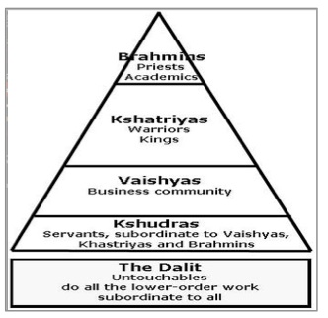
  - Bethlehem d. Jerusalem

- What religion is associated with the diagram to the left?
  - Christianity c. Buddhism
  - Hinduism d. Judaism

Five Pillars
      - Faith or belief in the Oneness of God and the finality of the prophet Muhammad.
      - Establishment of the daily prayers.
      - Concern for and alms giving to the needy.
      - Self-purification through fasting.
      - Pilgrimage to Mecca for those who are able.

- The religion mandates listed (Five Pillars) above come from what religion?
  - Judaism c. Islam
  - Hinduism d. Christianity

- What is the term for long narrative poems celebrating heroic deeds created by Greeks such as Homer?
  - Haiku c. Epics
  - Dramas d. Novels

- Which city-state was the center of Greek philosophy, art, and thought?
  - Troy c. Thebes
  - Sparta d. Athens

- Which factor aided in creating the Greek city-states?
  - Enormous deserts c. Mountainous terrain
  - Cold climate d. Tropical jungles

- A direct democracy allows who to rule the government?
  - Kings c. Emperors
  - The People d. the military

“As for me, all I know is that I know nothing.” – Socrates
“There is only one good, knowledge, and one evil, ignorance.” – Socrates
- What advice would a Greek philosopher like Socrates most likely give to their students?
  - Education is not important c. Education people have nothing left to learn
  - Ask questions to gain knowledge d. There is no reason to question the way things are done

“Our form of government does not enter into rivalry with the institutions of others. We do not copy our neighbors, but are an example to them. It is true that we are called a democracy, for the [government] is in the hands of the many, and not of the few… the laws secure equal justice to all.” – Pericles, 5th Century BCE
- According to Pericles, how did Athenian law treat it citizens?
  - Equally c. Harshly
  - Adequately d. Unjustly

- What was life centered around for Spartan men?
  - Military and training c. farming and hunting
  - Education and philosophy d. arts and literature

- Through his campaign of conquering much of the known world, Alexander the Great laid the foundations for which empire?
  - Macedonian c. Roman
  - Hellenistic d. Mesopotamian

Greek Gods | Roman Gods
Aphrodite Hera Demeter  Apollo Hermes Poseidon  Ares Hestia Athena  Artemis Kronos Persephone | Venus Juno Ceres  Appollo Mercury Neptune  Mars Vesta Diana  Diana Saturn Proserpina
- The chart above supports what classification of both Greek and Roman religion?
  - Monotheistic c. Polytheistic
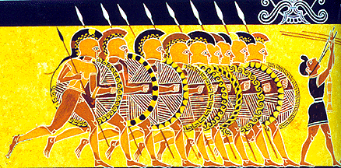
  - Christian d. Aristocracy

- The image to the left most likely is a depiction of which Greek Polis?
  - Athens c. Thebes
  - Sparta d. Crete

- Which of the following is one reason for the fall of the Roman Empire?
  - Attacks from Germanic tribes c. people didn’t want two emperors
  - Demands for women’s rights d. too much money

- What was built to move the Roman legion throughout the empire but also had the effect of helping to increasing trade?
  - Agriculture c. Pax Romana
  - Roads d. Aqueducts

- The Hellenistic Culture is made up of all but which of the following cultures?
  - Indian c. Roman
  - Greek d. Persian

- What were the Twelve Tables?
  - Furniture used by the Roman Senate c. The Roman code of law posted in the forum
  - Justinian’s code of law used in Byzantium d. Tablets used to decipher Latin

- What did the Romans design their government to do?
  - Promote trade c. Respond to military attack
  - Centralize power in one person d. balance the power of the government

- In early Roman government, who were the consuls?
  - The chief executives of the government
  - The representatives of the common citizens
  - Citizens of Rome and citizens of the provinces
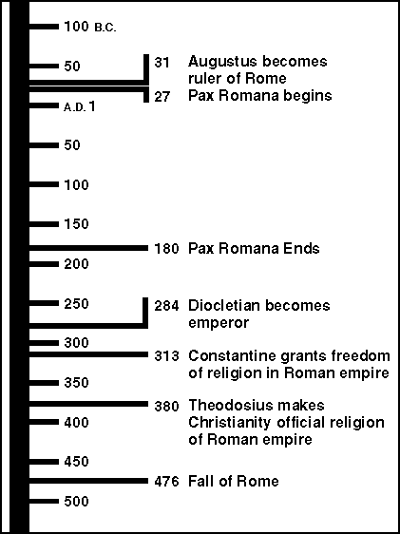
  - The executive and legislative branches of government

- Who was assassinated on March 15th by a group of conspirators in the Roman Senate?
  - Octavian c. Marc Antony
  - Julius Caesar d. Cleopatra

- In what year did Rome stop experiencing a time of peace and prosperity?
  - 31 BC (BCE) c. 284 AD (CE)
  - 180 AD (CE) d. 476 AD (CE)

- Which Emperor ended the persecution of Christians in the Roman Empire?
  - Trajan c. Julius Caesar
  - Diocletian d. Constantine

- Who were the wealthy, aristocratic landowners who held most of the power in the early republic?
  - Patricians c. Consuls
  - Plebeians d. Phalanx

- The eastern half of the Roman Empire was known as which of the following?
  - The Holy Roman Empire c. The Mongol Empire
  - The Byzantine Empire d. The Persian Empire
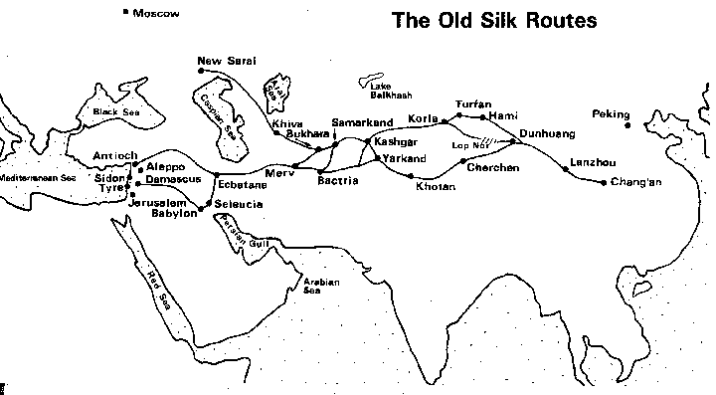

- According to the map, how was the Silk Road associated with the development of cities?
  - Increased trade along this route helped to establish cities within major empires
  - The development of many cities created a need for better roads
  - The Silk Road was built as an alternative to trade between large cities by the sea
  - European governments promoted free trade between major cities

- Japan relied on cultural diffusion with what other empire to create systems of writing and cuisine?
  - Egypt c. France
  - China d. Rome

- The military dictator who controlled the Samurai warriors of Japan was called what?
  - Lord c. Bushido
  - Shogun d. Serf

- In European feudal society, by which code did Knights live?
  - Bushido c. Feudalism
  - Chivalry d. The Pope

- What was the major purpose for the construction of Great Wall of China?
  - To encourage trade c. Provide protection from foreign invasion
  - To keep out crusaders d. Fencing used for farming practices

- During the Middle Ages, where did most people live?
  - Tents c. Castles
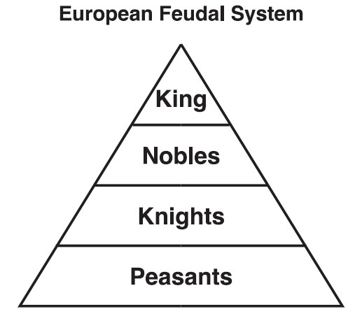
  - Manors d. Cities

- What government system does the diagram to the left illustrate?
  - Theocracy c. Feudalism
  - Militarism d. Canon Law

- How much influence did European women have during the Middle Ages?
  - They were part of the military c. They were very influential
  - They were not influential d. They ran the government

“… You must apple the strength of your righteousness to another matter which concerns you as well as God. For your brethren who live in the east are in urgent need of your help, and you must hasten to give them the aid which has often been promised them… For, as the most of you have heard, the Turks and Arabs have attacked them.”
- Who would have made the above statement?
  - Genghis Khan c. Saladin
  - Pope Urban II d. Vincenzo Medici

- How did the African kingdoms of Mali and Songhai gain their wealth?
  - Overseas exploration c. Going on a hajj to Mecca
  - Trade in gold, salt, and ivory d. Trade in silk, gun powder, and porcelain

Speaker A: We are born on this land and die on this land; our lives are the same as our family members before us.
Speaker B: We can be anyone we want to be! Through hard work and dedication we can achieve our dreams.
Speaker C: Our lives are simple and easy. There is never too much work to be done.
Speaker D: Our rights are always protected and made fairly. Our Lord cares about us!

- Which statement above would have most likely been made by a peasant during the Middle Ages?
  - Speaker A c. Speaker C
  - Speaker B d. Speaker D

- Under the feudal system, Lords would give land to peasants in exchange for what?
  - Money c. Labor
  - Credit d. Spices

- During the Crusades, Arab Muslims and European Christians both believed they were fighting for which purpose?
  - Wealth c. Education
  - Religion d. Treasure

- Which of the following was a result of the Crusades?
  - Lessened the power of women c. Increased the power of the Church
  - Expanded trade d. Settled religious conflict

- During the European Middle Ages, how could life in Africa and the Middle East best be described?
  - Golden Age c. Paleolithic Era
  - Pax Romana d. Dark Age

- What did Mansa Musa’s hajj to Mecca display to the world?
  - Four noble truths c. The Wealth of Mali
  - Africa’s poverty d. Exports from China

- Which areas of Europe were first affected by the Plague in 1347?
  - Isolated countryside c. Major trading ports on the Mediterranean
  - Northern coastlines d. Mountainous regions

- How can the Renaissance best be described?
  - An extension of the Middle Ages c. A rebirth of art and culture
  - A dependence on military force d. a dramatic change in farming techniques

- The Renaissance began in Italy because of its convenient access to what?
  - Trade c. Art
  - Education d. The Church

- Who best embodies the qualities of a “Renaissance Man?”
  - Genghis Khan c. King Henry VIII
  - Leonardo da Vinci d. Pope Urban II

- The invention of the printing press encouraged what in Europe?
  - War c. Education
  - Trade d. Socialization

- Who invented the printing press?
  - Leonardo da Vinci c. Niccolo Machiavelli
  - Martin Luther d. Johannes Gutenberg

Speaker A: The Pope is the head of the Church.
Speaker B: Salvation can be achieved through faith alone.
Speaker C: The Bible is not the absolute truth.
Speaker D: We are a polytheistic religion.

- Which of the following statements would have been made by a follower of Martin Luther following the Reformation?
  - A c. C
  - B d. D

- Which of the following statements would have been made by a follower of the Catholic Church?
  - A c. C
  - B d. D
- What major military event contributed to the loss of trust in the Catholic Church?
  - Civil War c. World War II
  - The Crusades d. Feudalism

- Which of the following describes a secular concern?
  - Maintaining faith in God c. Keeping up with daily prayer
  - Converting others to Christianity d. Keeping a job

- During what meeting did the Catholic Church decide to make changes to their practices?
  - Treaty of Paris c. Council of Trent
  - The Crusades d. Treaty of Versailles

- Predestination is the cornerstone of which religious leader’s teachings?
  - Martin Luther c. Pope Urban II
  - Henry VIII d. John Calvin

- Which document was written by Martin Luther and demanded reforms be made within the Catholic Church?
  - Magna Carta c. The Prince
  - 95 Theses d. The Qur’an

- What is the basic foundation of humanism?
  - Belief in the supremacy of the state in relation to individual rights
  - A rejection of ancient civilizations and their cultures
  - An emphasis on social control and obedience to national rulers
  - An appreciation for the basic worth of individual achievement

- In his book, The Prince, how did Machiavelli advise that rulers should get and keep absolute power?
  - Being a kind and just ruler c. making the people love you
  - By any means necessary d. making other people do the work

- The Medieval Catholic Church allowed people to gain forgiveness for their mortal sins through which practice?
  - Family gatherings c. Sale of Indulgences
  - Individual mediation d. Becoming the Pope

- What best describes Henry VIII’s reason for starting the English Reformation?
  - Sale of Indulgences c. Catherine Parr
  - Divorce d. War with Spain

- In what ways could the Maya and Aztec civilizations be considered similar?
  - Both showed little evidence of urbanization
  - Neither had strong central governments
  - Both developed complex mathematic and calendar systems
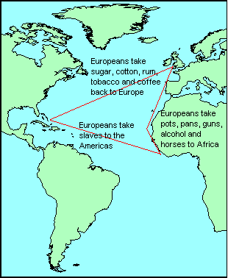
  - Their military weapons were superior to those of the Europeans

- What was an immediate result of the Age of Exploration?
  - Islamic culture spread across Asia c. Military dictatorships established in Europe
  - Independence movements in Asia d. European influence in the Western hemisphere

- How did the Aztecs expand their power?
  - Conquering other empires c. siding with the Europeans
  - Recruiting new members d. increasing immigration

- What is the section of the journey from Africa to the Americans called?
  - Slavery route c. Middle Passage
  - Third trip d. Trail of Tears

- What journey is the map to the left showing?
  - Columbian Exchange c. Crusades
  - Plantations d. Triangular Trade

- During the Age of Exploration, how could the American civilizations accurately be described?
  - Poor and uneducated c. Advanced and well developed
  - Chaotic and selfish d. Deserted and unorganized

- What assisted the Inca in controlling their vast empire?
  - Aqueducts c. Astrolabe
  - Roads d. Compasses

- The Native American population of Mexico in 1492 has been estimated at 25 million; the population by 1608 has been estimated at 1.7 million. This decrease in population was mainly a result of what?
  - Crop failures c. Disease brought by Europeans
  - Mass executions d. Wars between tribes

- What were empires like England hoping to acquire when they established colonies in the new world?
  - Natural resources c. Industry
  - Slaves d. Weapons

- What king became France’s most powerful ruler and boasted “I am the state?”
  - Henry II c. Philip II
  - James IV d. Louis XIV

- Why did Peter the Great build the city of St. Petersburg?
  - To maintain feudalism in Russia c. He didn’t like the city of Moscow
  - To ease travel to Asia d. To westernize Russia like European cities

- Which absolute monarch is given credit for defeating the famed Spanish Armada?
  - Phillip II c. Louis XIV
  - Peter the Great d. Elizabeth I

- Where did absolute monarchs get the money to continually wage war and obtain luxury items?
  - Personal slavery c. Inheritance
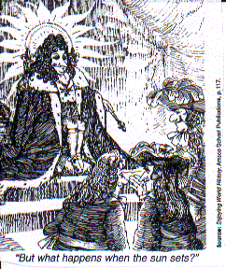
  - Taxation d. Royal courts

- What type of government did Louis XIV, as pictured to the left, have in France?
- A socialist republic c. Communist regime
- An absolute monarchy d. A democracy

- What made Philip II considered a defender of the faith by the Catholic Church?
  - Removing the Muslims from Spain
  - Translating the Bible into the vernacular
  - Promoting the 95 theses
  - Helping the pope win a game of chess

- What was the condition of France following the death of Louis XIV?
  - A golden age c. Heavily in debt
  - Medieval feudalism d. A democracy

- Sir Isaac Newton is famous for developing which method of mathematics?
  - Physics c. Calculus
  - Biology d. Algebra

- When the Third Estate was denied proper representation in the Estates-General, they reformed and called themselves the
  - San-Culottes c. Montagnards
  - National Assembly d. Jacobins

- What was the name of the time period when the French lived in fear of constant executions?
  - Era of Fear c. Eon of Horror
  - Kingdom of Tears d. Reign of Terror

- This document, which King John was forced to sign, greatly limited the power of the monarch.
  - Tennis Court Oath c. Magna Carta
  - Estates-General d. Mayflower Compact

- Which 18th century enlightenment thinker developed the concept of the social contract?
  - Baron de Montesquieu c. John Locke
  - Jean Jacque Rousseau d. Thomas Jefferson

- The group of rich businessmen who easily accepted the ideas of the enlightenment in France were the
  - Aristocracy c. Sans-Culottes
  - Bourgeoisie d. Clergy

- The Third Estate stormed which prison and armory after discovered the threats of an incoming foreign army?
  - Turielles c. Bastille
  - Versailles d. Vendee

- What was the purpose of the Watch Committee under the Revolutionary Tribunal in Paris?
  - Watch out for the leftist radicals in Paris
  - Keep an eye on foreigners and suspects of treason
  - Look for any way to help out the poor peasants of France
  - Be aware of the movements of the rich in Paris

- The document which gave rights to all men of France was called the
  - Declaration of Independence c. Declaration of the Rights of Man and the Citizen
  - Bill of Rights d. Declaration of Civil Government

- Which of the following is not considered to be a natural right according to John Locke?
  - Life c. Liberty
  - Pursuit of Happiness d. Property

- Which title did Napoleon adopt after his successful coup d’estate?
  - Estates-General c. Royal King of All Europe
  - First Consul d. Caesar

- What was the function of the Napoleonic Code?
  - Reform the legal system so that it is uniform in all of France
  - Divide up property confiscated from noblemen
  - Teach the youth of France right from wrong
  - Strip all Frenchmen of titles so that everyone is the same

- This former salve led a successful revolution in Haiti to gain independence from France.
  - Toussaint L’Overture c. Simon Bolivar
  - Miguel Hidalgo y Costilla d. Napoleon Bonaparte

- The Russian army hoped that its ___________________________ and ______________________ would help to defeat the incoming French Grand Armee.
  - Size/Generals c. Weather/Pride
  - Size/Weather d. Weather/Generals

- This leader of the Mexican Revolution believed that Mexicans deserved to govern themselves without the dominant peninesulares.
  - Toussaint L’Overture c. Simon Bolivar
  - Miguel Hidalgo y Costilla d. José de San Martin

- The Venezuelans fighting for independence looked to which leader for assisted in gaining their freedom?
  - Toussaint L’Overture c. Simon Bolivar
  - Miguel Hidalgo y Costilla d. José de San Martin

- Which Argentinean helped led to the emancipation of Argentina, Chile, and Peru in the early 19th century?
  - Toussaint L’Overture c. Simon Bolivar
  - Miguel Hidalgo y Costilla d. José de San Martin

- Where did the Industrial Revolution begin?
  - United States c. Spain
  - France d. England

- Immediately before the Industrial Revolution, where did most people live?
  - Apartment buildings c. Farms
  - Castles d. Feudal manors

- Which of the following statements is true about the early Industrial Revolution?
  - People worked long hours for very little pay
  - Cities were improving and growing at a slow rate
  - Education was at its prime and all children had the option of free schooling
  - Housing and sanitation dramatically improved

- What was the major effect of the enclosure system in England?
  - All agricultural workers benefited from the new system
  - It became easier to implement new agricultural technologies
  - It discouraged advancement in the field of agriculture
  - It was optional, so many people refused to participate

- During the Industrial Revolution, people often worked for how many hours per day?
  - Most did not work c. Approximately 8
  - More than 10 d. Less than 5

- Which group of people most benefitted from the Industrial Revolution?
  - Workers c. Children
  - Farmers d. Factory owners

- Between which two groups did a widening gap develop during the Industrial Revolution?
  - Farmers and laborers c. Kings and Senators
  - Rich and poor d. Young and old

- During the Industrial Revolution, what often happened to employees who complained about poor conditions?
  - They were given a raise c. They could sue the company
  - They quit and found another job d. They were quickly fired and replaced

- Theories such as socialism, Marxism, and communism were especially attractive to what group?
  - Workers c. Children
  - Farmers d. Factory owners
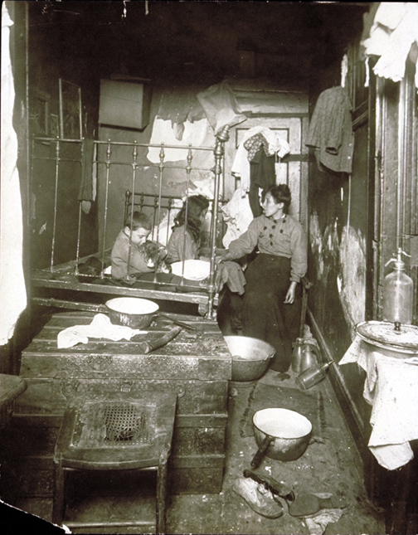
Based on the photograph to the left, how can living conditions for laborers during the Industrial Revolution best be described?
  - Roomy and comfortable
  - Cramped and crowded
  - Luxurious and spacious
  - Similar to the conditions of today

- Why were factories built so close together?
  - Access to natural resources was limited
  - Cities were very small
  - There was a lack of building materials
  - More people could be easily watched

- Which man advocated for the adoption of the capitalist system throughout Europe?
  - Adam Smith c. Karl Marx
  - Friedrich Engels d. Jacob Riis
“A country is not merely a geographic territory. A country is also the idea given birth by the geographic territory. A country is a sense of love that unites, as one, all the sons and daughters of that geographic territory.” – World History: A story of Progress

- The above quotation supports which of the following ideas?
  - Imperialism c. Nationalism
  - Militarism d. Capitalism

- Nationalism ultimately caused the breakup of which empire?
  - Austria-Hungary c. Germany
  - Ottoman d. Spain

- Which concept describes Otto von Bismarck’s tough political philosophy?
  - Mercantilism c. Realpolitik
  - Realism d. Nationalism

- Which nation did Camilio di Cavour and Guiseppe Garibaldi help to unify?
  - Germany c. Hungary
  - Poland d. Italy

- After the Industrial Revolution, the demand for raw goods increased. What was the ultimate impact on imperialism?
  - There was no relationship between the Industrial Revolution and imperialism
  - There was a decrease in the interest in imperialism
  - There was an increase in the demand for imperialism
  - The Industrial Revolution ultimately ended the desire for imperialism

- Imperialism was encouraged by the desire for large nations to dominate smaller nations in the search of
  - New technology c. Raw materials
  - Governments d. Religion

- The Berlin Conference regulated the division of which continent?
  - North America c. Europe
  - South America d. Africa

“Take up the White Man’s burden –
Send forth the best ye breed –
Go send your sons to exile
To serve your captives’ need
To wait in heavy harness
On fluttered folk and wild –
Your new-caught, sullen peoples,
Half devil and half child…”

- According to the poem “White Man’s Burden” by Rudyard Kipling, which of the following ideas was supported throughout Europe?
  - Native peoples are self-sufficient and advanced
  - Europeans have an obligation to spread their culture around the globe
  - Europeans have nothing worth sharing with the world
  - The subjects of European colonies were very intelligent

- Which term describes the adoption of a conqueror’s culture by the people of the conquered nation?
  - Assimilation c. White Man’s Burden
  - Social Darwinism d. Ethnic cleansing

- What was the primary goal of the Boxer Rebellion and the Sepoy Mutiny?
  - Eliminate poverty among the peasants
  - Bring western-style democracy to the nation
  - Restore trade relations between their nation and Europe
  - Remove all foreign influences

- How did the Chinese emperor respond to the early attempts by Europeans to create a favorable balance of trade?
  - He welcomed European goods c. He hoped for an increase in the opium trade
  - He saw no need for any European goods d. He knew China was heavily dependent on Europe

- From an analysis of the Russo-Japanese War and the Boer War, what is one conclusion that can be made for a reason that nations go to war?
  - To assist oppressed peoples c. to spread religious beliefs
  - To satisfy imperialistic goals d. to honor provisions of a treaty

- Which of the following is often considered to be the immediate cause of World War I?
  - The bombing of Pearl Harbor c. The invasion of neutral Belgium
  - The switch of Italian allegiance d. The assassination of Archduke Franz Ferdinand

- Prewar alliances created a domino effect, which eventually caused what nations to form the Allied Powers?
  - Austria-Hungary, Germany, and Italy c. Spain, Switzerland, and Belgium
  - Russia, France, and Britain d. Ottoman Empire, Bosnia, and Greece

- Which nation changed alliances midway through the First World War?
  - Russia c. Germany
  - Italy d. Great Britain

- Which of the following technologies, developed in the early 20th century, changed the way ways were fought following World War I?
  - Computers, jets, and nuclear weapons c. Cavalries, swords, and pistols
  - Ships, rifles, and cannons d. Airplanes, poisonous gases, and machine guns

- Which of the following terms describes the enthusiastic building up of a military force?
  - Alliances c. Imperialism
  - Nationalism d. Militarism

- Civilians become targets, as well as victims of combat
- Nations devote all resources – political and economic – to the war effort
- Civilians become active participants in the war effort by producing war goods
- Nations try to demoralize their enemies by making them victims of attacks
- According to the list above, which of the following terms is being described?
  - Stalemate c. Propaganda
  - Total War d. Attrition
- Which modern military weapon was responsible for the sinking of the Lusitania in 1915?
  - Nuclear weapons c. Poison gas
  - U-boats d. Grenades

- What was Germany’s early military strategy for fighting a two-front war?
  - Reparations c. Schlieffen Plan
  - Treaty of Versailles d. Self-determination

- On November 11, 1918, what was signed to officially end the fighting of World War I?
  - An armistice c. A military order
  - A treaty d. A court order

- During the Russian Civil War, which former leader of Russia was executed?
  - Nicholas Romanov c. Franz Ferdinand
  - Vladimir Lenin d. Arthur Zimmermann

- Why did the Russians decide to leave the fighting of World War I?
  - They had suffered too many causalities
  - They had a revolution occurring at home
  - They decided that they did not want to fight alongside American soldiers
  - They wanted the Germans to win

- Due to which treaty were the Russians able to stop fighting in World War I?
  - Treaty of Versailles c. Treaty of Ghent
  - Treaty of Brest-Litovsk d. Treaty of Paris

“Every peace-loving nation… wishes to live its own life, determining its own institutions, be assured of justice and fair dealings by the other peoples of the word by force or selfish aggression.” – Woodrow Wilson
- What idea is described in the above quotation?
  - Self-determination c. Imperialism
  - Nationalism d. Social Darwinism

- Which of the following statements best describes reparations?
  - Germany had to disarm and disband the majority of its military.
  - Germany had to pay the cost of injuries to civilians and damage to their property.
  - Germany had to accept full responsibility for the World War I.
  - Germany had to surrender all of her colonial territories.

- What was the ultimate purpose of the Treaty of Versailles?
  - Proclaim a winner of World War I c. Create new nations
  - Weaken Germany d. End the use of trench warfare

- What was the name of the ideas for ending World War I provided by US president Woodrow Wilson?
  - Tennis Court Oath c. Declaration of War
  - Fourteen Points d. Rights of Man

- Why did the United States refuse to join the League of Nations?
  - They didn’t like the Europeans c. They didn’t want to give up any of their power
  - They were hoping for future wars d. They didn’t like it because it was Wilson’s idea

- Which of the following helped Adolf Hitler gain power in Germany?
  - Promise of new democracy c. Support of the Weimar Republic
  - Big business and labor d. Anger felt by Germans at the Treaty of Versailles
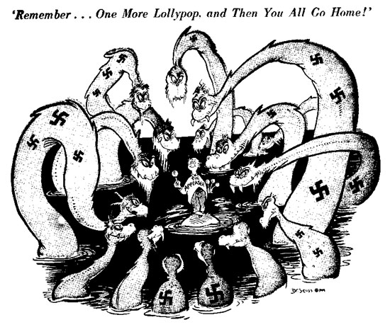
- What government policy does the cartoon to the left illustrate?
  - Militarism c. Spending cuts
  - Appeasement d. Imperialism

- Which was a characteristic of Germany under Hitler and the Soviet Union under Stalin?
  - An official foreign policy of isolationism
  - Public ownership of business and industry
  - The absence of laws
  - Government control of the media

- What was the purpose of the Kellogg-Brian Pact?
  - Establish military alliances c. End war as a political tool
  - Establish German borders d. Promote economic
cooperation among nations
- Which leader officially established the Fascist party in Italy?
  - Adolf Hitler c. Joseph Stalin
  - Benito Mussolini d. Hideki Tojo

- Which action did Hitler take which violated the Treaty of Versailles?
  - Built up Germany’s military c. began a genocide
  - Ended his alliance with the USSR d. Refused to join the League of Nations

- Just before World War II, which group of people took over control of the government in Japan?
  - Nobles c. Military
  - Clergy d. Peasants

- Why did Hitler sign the non-aggression pact with the Soviet Union in 1939?
  - Hitler did not want to fight a two front war
  - Stalin wanted to make sure he had time to prepare for a war
  - Churchill suggested it at the Munich Conference
  - Wilson required all members of League of Nations to sign one

- What military strategy did Germany use when they invaded Poland in 1939?
  - Kamikaze c. Isolationism
  - Rolling Thunder d. Blitzkrieg

- The Battle of Britain in 1940 can be classified as which type of battle?
  - Trench c. Hand-to-hand
  - Air force d. Naval

- D-Day refers to which military operation?
  - Allied invasion of France c. The end of World War II
  - Entry of the US into WWII d. British victory in North Africa

- Which nation suffered the greatest number of causalities in World War II?
  - France c. Soviet Union
  - United States d. Germany

- Why did the Japanese decide to invade Manchuria?
  - Cultural diffusion c. The desire for natural resources
  - New technology d. More room to expand their population

- Which of the following sites contained the naval base which was attacked by Japanese forces on December 7, 1941?
  - Dunkirk c. Hiroshima
  - Pearl Harbor d. Stalingrad

- To what does “The Holocaust” refer?
  - The bombing of London c. Massacre of more than ten million “undesirables”
  - Mobilization of total war d. turning point of the war in North America

- Which of the following was destroying by an atomic bomb dropped by the United States in 1945?
  - Berlin, Germany c. Tokyo, Japan
  - Pearl Harbor, Hawaii d. Hiroshima, Japan

- Which country was most of the sites of the Nazi extermination camps?
  - Poland c. Soviet Union
  - Germany d. Hungary

- Which term describes a neighborhood within a city in which Jewish people were forced to live?
  - Aryan c. Holocaust
  - Genocide d. Ghetto

- Which important principle was established as a result of the Nuremberg Trials?
  - Defeated nations have no rights in international courts of law
  - Individuals can be held accountable for “crimes against humanity”
  - Soldiers must follow the orders of their superiors
  - Aggressor nations must pay war reparations for damages caused during wars

- What American military strategy, used by the Pacific campaign, helped contribute to the Allied victory over Japan?
  - Genocide c. Nuclear War
  - Trench Warfare d. Island Hopping

- Hiroshima and Nagasaki were both bombed as a result of which secret American operation, led by J. Robert Oppenheimer?
  - Manhattan Project c. D-Day
  - The Red Scare d. Area 51

- Which of the following is an outcome of World War II?
  - England and France increased their overseas colonial possessions
  - The communists gained control of most of western Europe
  - Japan and Germany became dominant military powers in their regions
  - The Soviet Union and the United States emerged as international superpowers

D
C
B
A

1900 1920 1940 1960 1980 2000

- Using the timeline above, which portion describes the era of the Cold War?
  - A c. C
  - B d. D

- What were the nations surrounding the Soviet Union, including East Germany and Hungary, called?
  - Buffer Zone c. Iron Wall
  - Soviet Union Cities d. Berlin

- What was done to Germany following World War II in an effort to control the region?
  - Reduction in agricultural development c. Division of the nation
  - Constant bombing raids d. Destruction of the Berlin War

- The Berlin War was constructed by which nation?
  - United States c. Germany
  - France d. Soviet Union

- Under which plan were the former Allied Powers able to get supplies in the Soviet blockaded West Berlin?
  - Berlin Wall c. Berlin Blockade
  - Berlin Airlift d. Berlin Crisis

- Under the concept of which theory did Eisenhower feel justified in US intervention in Vietnam?
  - Iron Curtain c. Marxism
  - Domino Theory d. Communist Theory

- What policy did the United States use to try and stop the spread of communism?
  - Berlinism c. Domino Theory
  - Containment d. Socialism

- In response to the formation of NATO, the Soviet Union formed which group?
  - Western Bloc c. Fascist Party
  - Munich Group d. Warsaw Pact

- The House Un-American Activities Committee was led by whom?
  - Senator Joseph McCarthy c. President Franklin Roosevelt
  - Secretary of State Kennan d. Vice President Harry S. Truman

- What was one major result of the Cultural Revolution in China?
  - Mass executions c. Famine
  - Increase in higher education d. Freedom of the press

Speaker A: People have no freedom and are under total control by their leader.
Speaker B: People do not pay much attention to their leader, but only to their families.
Speaker C: People are very peaceful in North Korea, there is no resentment from the Korean war.
Speaker D: The borders are open and people are encouraged to go to school in other nations.
- Which speaker accurately portrays life in North Korea today?
  - A c. C
  - B d. D

- What was most responsible for the fall of the Soviet Union?
  - Space Race c. Berlin Airlift
  - Cuban Missile Crisis d. Perestroika

- Which leader established a communist dictatorship in Cuba in 1959?
  - Fidel Castro c. Adolf Hitler
  - Nikita Khrushchev d. Joseph Stalin

- What did the Soviet attempt to build in Cuba in the early 1960s?
  - Gulags c. Nuclear Missiles and Silos
  - Naval ports d. Competing factories

- Who did the United States supply weapons to in order to stop the spread of communism in Afghanistan?
  - Soviet soldiers c. Refugees in Czechoslovakia
  - United States military d. Mujahideen rebels

- What unintended consequence did the conflict in Afghanistan have on the United States?
  - Increase in nationalism c. Development of terrorism
  - Reinstitution of imperialism d. Socialism

- What was the ultimate goal of the Marshall Plan and the Truman Doctrine?
  - To create democratic governments in Eastern Europe
  - To stop the spread of communism through economic support of Europe
  - To develop more powerful nuclear weapons
  - To remove nuclear weapons from Cuba

- Which world organization formed after World War II works to support member nations and prevent war?
  - United Nations c. League of Nations
  - World Trade Organization d. European Union

- What trend on world population has been observed by the United Nations?
  - A steady increase in all regions of the world
  - An exponential growth, especially in developing nations
  - A decrease, mostly likely resulting in a population of 5 billion by 2050
  - No noticeable change in world population trends

- Which organization provides grants, loans, and advice for economic development?
  - United Nations c. World Trade Organization
  - World Bank d. European Union

- Which trading bloc consisting of 27 European nations has become the world’s largest single trading entity?
  - NAFTA c. GATT
  - APEC d. EU

- Which invention in 1971 revolutionized the computer industry by allowing for the development of PCs?
  - Microprocessor c. RAM
  - World Wide Web d. The Internet

- In 1990, the launch of this telescope has allowed scientists to gather large amounts of information on the solar system.
  - Explorer c. Hubble
  - Spirit d. Opportunity

- Which of the following is an example of the use of bioterrorism?
  - September 11, 2001 attacks c. Oklahoma City bombing
  - The anthrax attacks on US citizens d. Kamikaze attacks during WWII

- As science continues to develop at a rapid pace, the moral questions that are raised as known as a concern over
  - Bioethics c. Due process
  - Technology d. violation of human rights

- The Green Revolution, which aided in the development of new strains of rice and corn, also led to the development of
  - New forms of governments c. concerns over inflation
  - More world hunger issues d. Genetically modified foods

- What is the formation of degraded soil which turns semiarid lands into nonproductive regions?
  - Deforestation c. Rain forest decimation
  - Desertification d. Desalination

- What global treaty has led to a reduction in carbon dioxide emissions around the world?
  - Treaty of Versailles c. Geneva Accords
  - Chernobyl Agreement d. Kyoto Protocol

- What is the estimation of those suffering from hunger around the world?
  - 500 million c. 2 billion
  - 1 billion d. 4 billion
- What is the process of expelling and/or killing large numbers of an unwanted ethnic or religious group?
  - Ethnic cleansing c. Gulag
  - Deportation d. Population transfer

- In 1948, the United Nations affirmed the basics of all privileges of humanity with the
  - Declaration of the Rights of Man and the Citizen
  - Declaration of Independence
  - Universal Declaration of Human Rights
  - Human Rights Movement Declaration

- This terrorist group in Northern Ireland has repeatedly tried to reunite British controlled Northern Ireland with the independent Irish Republic.
  - NATO c. NAFTA
  - PLO d. IRA

- In response to the terrorist attack on the United States on September 11, 2001, President Bush established the Patriot Act which allowed
  - The establishment of internment camps in the continental United States
  - Wiretapping the phone lines of suspected terrorists
  - The deportation of American citizens to Europe
  - The establishment of military zones in New York City and Washington DC

